The Official Publication of ALOA—An International Association of Security Professionals

Don't Judge a Safe by Its Cover

**uuwvu.aloa.org**

Mils: LAB Connects with Institutional Pros, New Frontiers in Key Extraction • Investigative Locksmithing • and more.

iet your annual ALOA Board **[lection profiles Inside (page 38)**

**May 2003**

and more.

The SAFETECHer Who Crossed the  
Country on an Emergency Vault Job

S&G's Little Lock  
That Could

, . * # S / i I

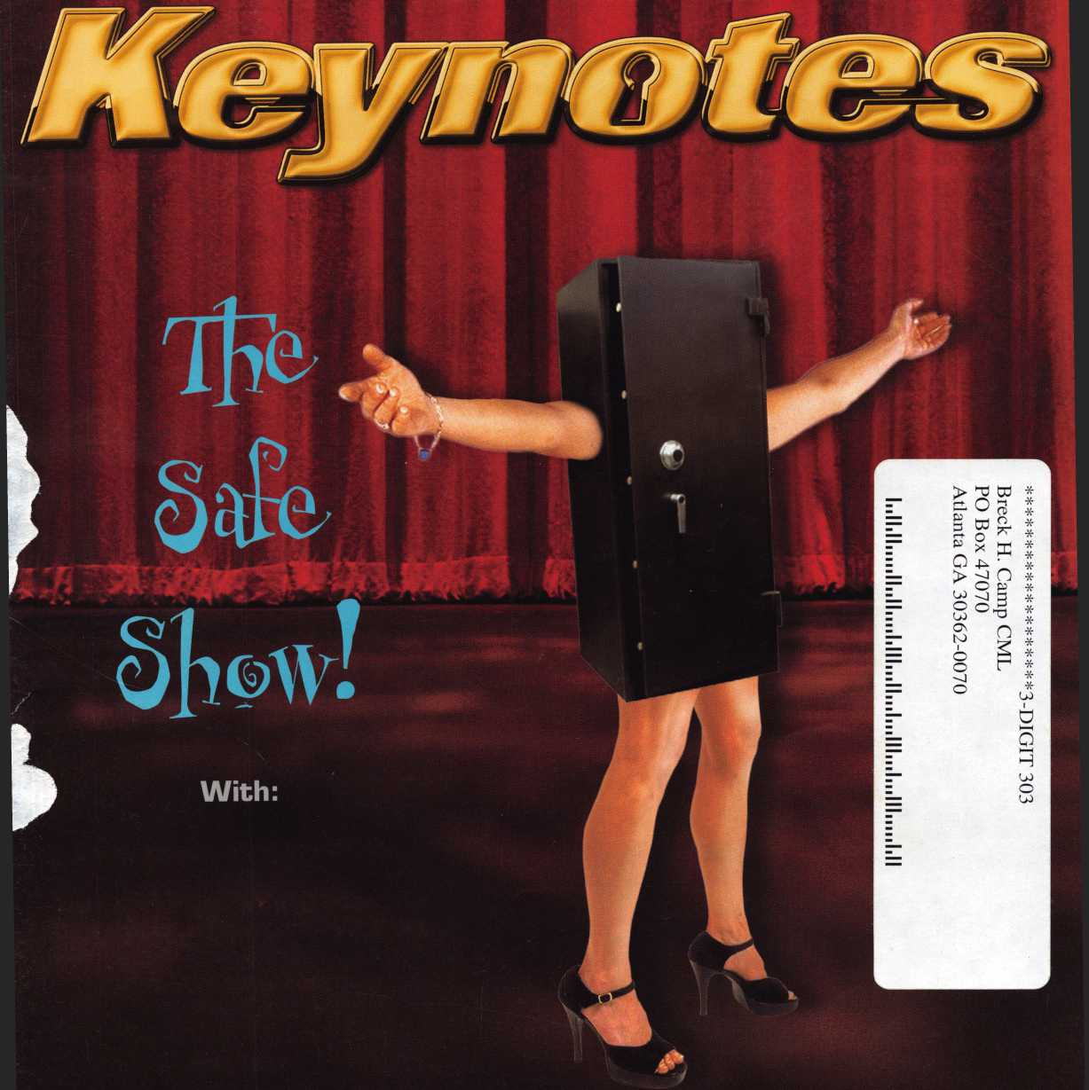

Keep Your Day Job

Come to Las Vegas and invest in your future as a security professional.

Discover classes, workshops, and exhibits that will keep you competitive in today’s marketplace.  
Las Vegas Hilton/Las Vegas Convention Center • July 14-20, 2003

The only gamble is staying home

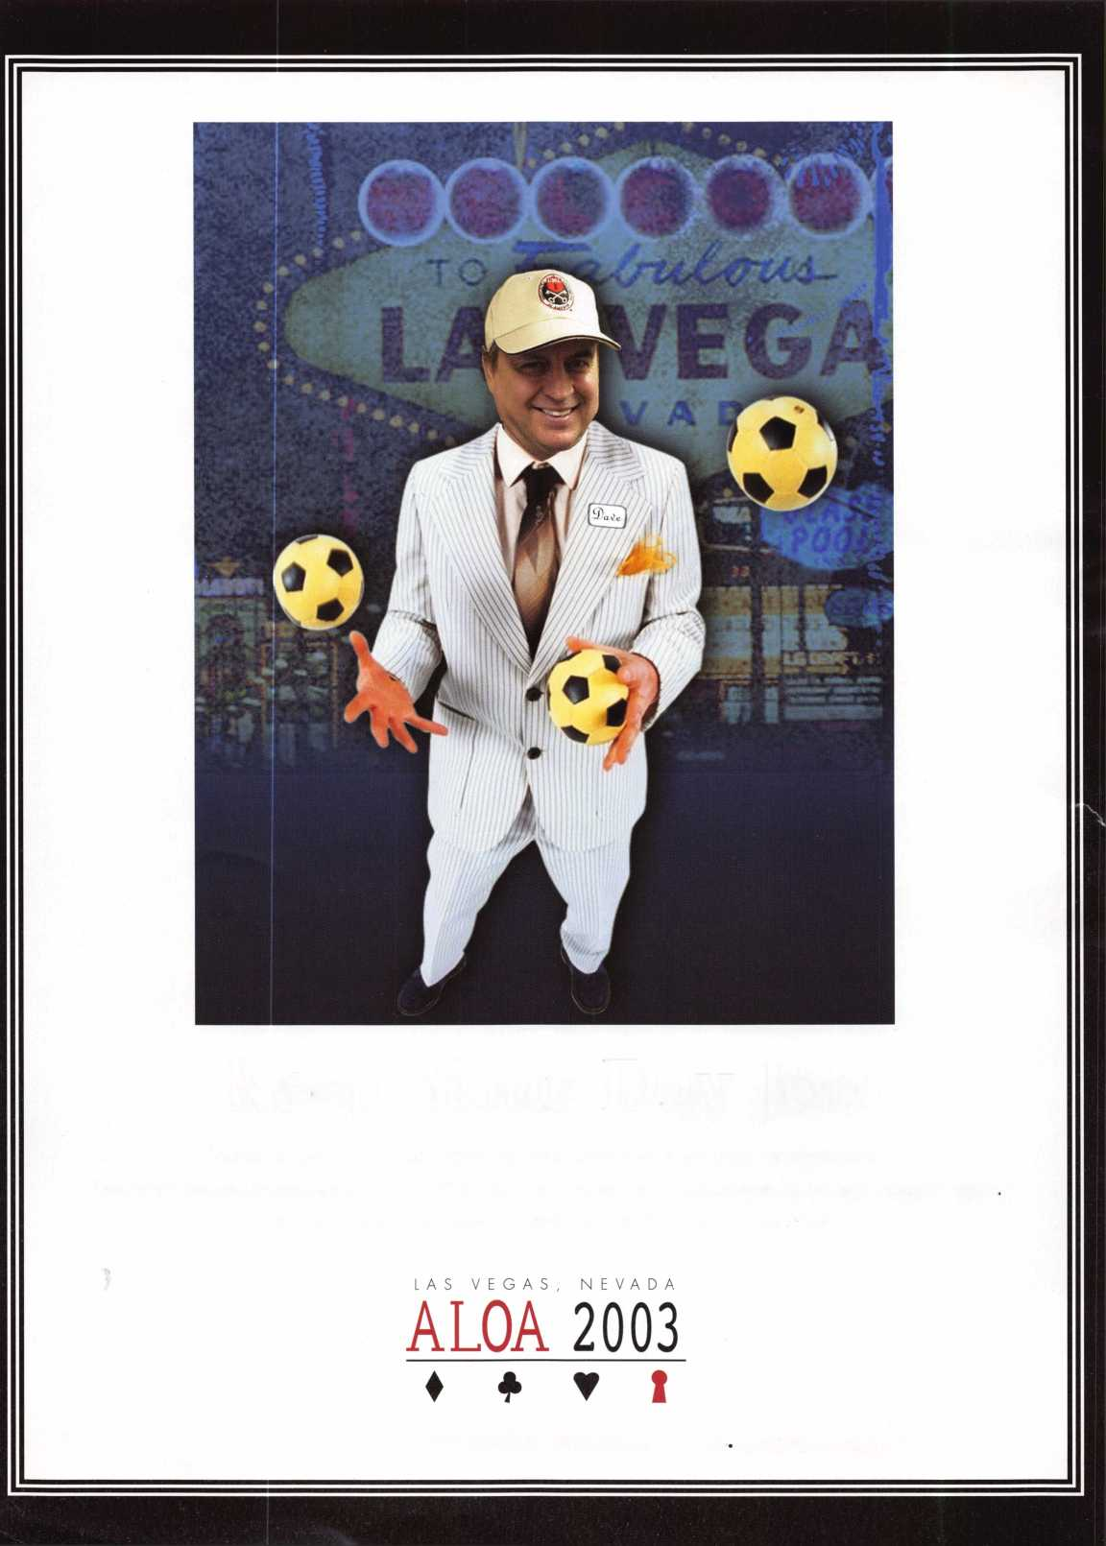

< rwo^ s

CEN.XXXXXX

kabakoupon

The Kaba Mas Dealer Network is the second phase of our new distribution channel that includes sales support, technical support services, product development and technical training classes. The first step was to create a network of wholesalers - the Wholesale Network - who all received extensive in-house training on all of our products and are supported by our internal and external sales team. By providing our distribution channel with education and sales support, they are better equipped to service your product needs.

KARA

**The Brand for Safe Locks**

*\ n i*

A Member of the Kaba Group

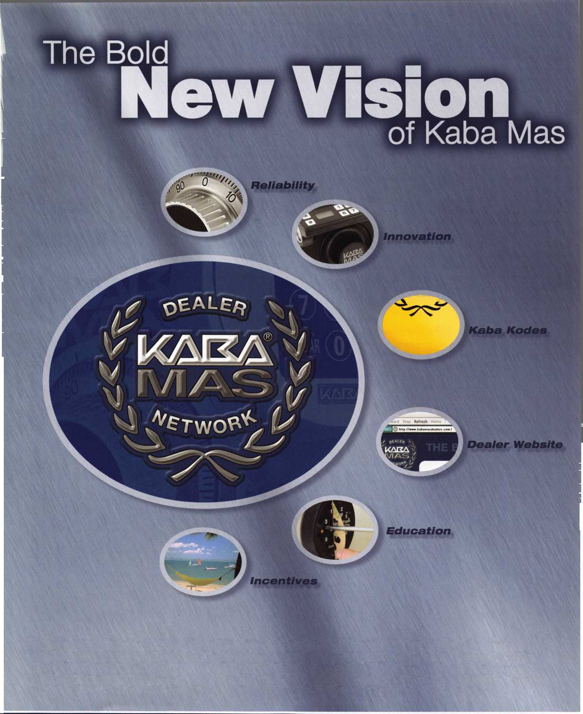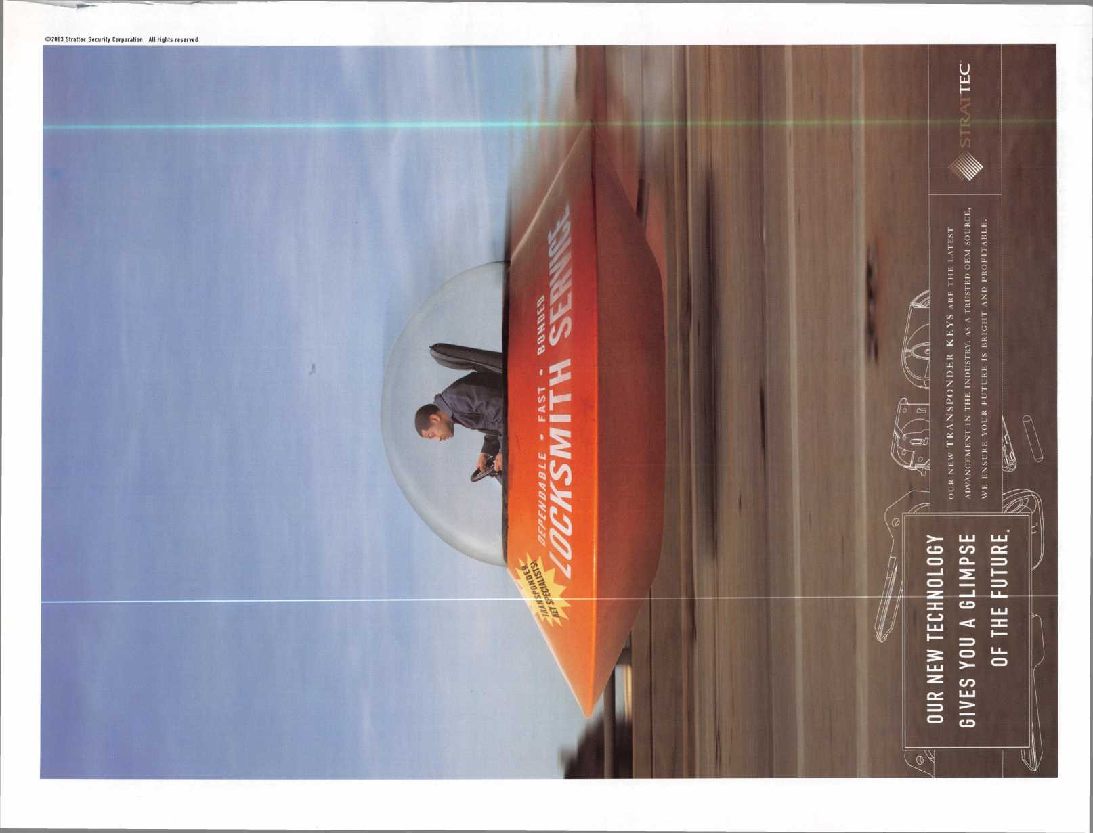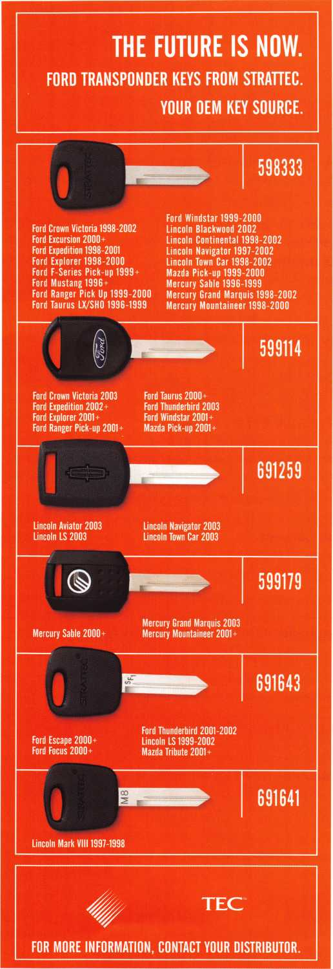

SafeData

Greg Perry, CML, CPS

Open up your library! SafeData allows you  
to find the information you've invested in,  
fast. This one program has over  
8500 listings of magazine, books,  
ClearStar Security Network posts  
and my personal library. Each listing  
includes not only the book or magazine, the  
issue, the title, the author and the page, but  
it also lists the lock and the hand of the lock  
(when available). SafeData lists patent  
dates and other trivia that may  
help in identifying a container or lock.

SafeData also has picture folders represent-  
ing over 90 different manufactures of safes  
and locks with over a thousand pictures.  
Some models include a text file giving gen-  
eral information on size and relock loca-  
tions. Plus you can add your own informa-  
tion and update it yourself or purchase the  
annual updates.

SafeData is available exclusively from  
ALOA. Normal price for this CD is $249.95.  
Price includes two installs! Put it on your  
desktop and your laptop.

Special Introductory offer

includes your first update!

$199.95

To order contact ALOA (800) 532-2562

f

e

a

t

u

res

Institutional

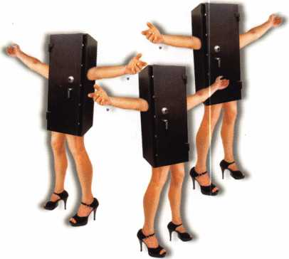

**departments**

Executive 6

Applicants 7

Calendar 8

Core 34

Legislative Update 36

Classifieds 40

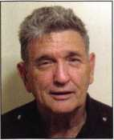

Associate

Members 42

Back Page 44



The Little Lock That Could By Brian Costly, CML, CMST

I have no idea whether it "thought it could...thought it could," but the little lock in S&G's Test Lab definitely did it. The standard 6730 ran 160,986 cycles without a single failure. I was betting on 250,000 cycles, but the test was stopped because the dialing fixture was needed for another test, so well never know.

**16**

Don't judge a safe by its cover:

What it says on the outside is not

always what's on the inside! ByCreg Perry, cml, cps

Sometimes, just because a safe claims a certain parentage doesn't mean the label is correct. When a manufacturer has a need for a safe they don't current­ly produce, they may buy it from a competitor and put their own label on it.

Or, as they buy up the competition, they may continue to produce safes using the bought up company's designs, but put their label on the safes.

**18**

"The call came in like this":

SAFETECH Participant Crosses the country twice during San Diego

show to open a vault in New Jersey By Kenny Hiemstra Jr.

While I was teaching professional safe opening with Ron Jewel on the second day of classes at this year's SAFETECH show in San Diego, my cell phone was ringing off the hook. During the break, I checked my voicemail and was told my services were greatly needed to open a bank vault in my home state of New Jersey.

**20**

Solving a Vault Lockout By Merritt Perkins, RL

A woman called me on the telephone for help because she could not open the vault in her store building. The vault and her business were on the first floor and she was living on the second floor. The vault was installed when the build­ing was remodeled, about 1920. The vault was intended to store records.

**22**

Is Investigative Locksmithing in Your Future?bxciaire l. Cohen, cml Before he died, one of former ALOA Board Director Jim Glazer's dreams was to form a group who could work together to further professional knowledge in investigative locksmithing. In 1998, Jim's dream became a reality with the for­mation of The International Association of Investigative Locksmiths (IAIL).

**26**

The Customer Isn't Always Right **ByEncCos^cRL**

Running a business means a great deal more than simply pleasing a customer.

**30**

The New Frontiers of Key Extraction bx Don Dennis, cpl

Only in the last 10 years has key extraction become an item of importance with tool manufacturers. Before this period, it was a time when new tools and ideas on extraction were rare with most of the attention restricted to minor com­ments. The justification for this probably lies in the mindset that patience was the only good tool for the endeavor. The lack of tools being produced only reaffirmed manufacturing oversight in knowledge of a normal and daily lock­smithing experience.

Visit our website at [www.aloa.org](http://www.aloa.org)

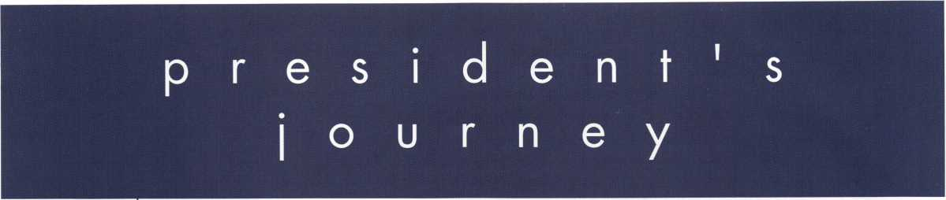

When it has to be secure, put it in a safe. Not just a safe, but a safe that is rated for your task. I was just at SAFETECH for the annual SAVTA convention in sunny San Diego. It gives you a little bit of an ego boost to see all the heavy tools and cool products. Or possibly, it could deflate your ego to see how your competition is moving ahead with or without you. When you see the best products, the best tech­nicians, at the best convention for safes and vaults, it's a good feeling just to know you are a part of it. This issue of Keynotes covers safes and vaults. I hope you find information you can use in your business. I would like to also encourage anyone who is not a member of SAVTA to consider joining. Please contact the ALOA office at 800/532-2562 for more information. This summer, from July 14-20, is the ALOA Security Expo, to be held in Las Vegas. You will find a full venue of safe classes at this show, in addition to many others covering all the different specialties in our indus­try. Look inside this issue (or in your convention brochure, which was recently mailed to you) for dates and classes. I hope that you are able to participate and grow in your business and expertise.

See you next month, Randy Simpson, CML

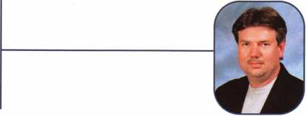

Keynotes •

May 2003

executive

Volume 49, Issue 5



Additional contact information for the ALOA Board and most Keynotes authors is  
available through "Locksmith Search'" on the ALOA Web site- [www.aloa.org](http://www.aloa.org) or by  
contacting the ALOA office at 3003 Live Oak Street; Dallas, TX 75204; (800)532-2562;  
FAX (214)827-1810; e-mail [aloa@aloa.org](mailto:aloa@aloa.org).

|  |  |
| --- | --- |
| Editor  Jim DeSimone | [editor@aloa.org](mailto:editor@aloa.org) |
| Technical Editor  David Lowell, CML, CMST .... | [david@aloa.org](mailto:david@aloa.org) |
| Editorial Advisor  John D. Cannon, CML | [jdcannon@worldnet.att.net](mailto:jdcannon@worldnet.att.net) |
| Art Director  Betty Henderson | [betty@aloa.org](mailto:betty@aloa.org) |
| Advertising Sales  Kim Hammond | voice: 817-645-6778  Fax: 817-645-7599 e-mail: [adsales@aloa.org](mailto:adsales@aloa.org) |
| Executive Director  Charles W. Gibson, Jr., CAE | [charlie@aloa.org](mailto:charlie@aloa.org) |

Convention & Meetings Manager

Jo Anne Mims [joanne@aloa.org](mailto:joanne@aloa.org)

PRP/Education Manager

David Lowell, CML, CMST [david@aloa.org](mailto:david@aloa.org)

Operations/Membership Manager

Mary May [mary@aloa.org](mailto:mary@aloa.org)

IT Operations Manager

Greg Jackson [greg@aloa.org](mailto:greg@aloa.org)

Comptroller Kathy J. Romo

Membership Coordinator Shelly Jett

Convention & Meetings Assistant Karen Lyons  
PRP/Education Coordinator Janelle Ramirez

Accounting Coordinator Stephanie Brothers

Mail Room Coordinator Kevin Wesley

Receptionist Shawn Alvear

Contributors

Jerome Andrews, CML  
Paul Chandler, CRL  
Claire Cohen, CML  
Brian Costley, CML, CMST  
Ray D'Adamo, CML

Sal Dulcamaro, CML Billy Edwards, CML Dan Graffeo, CRL,CMST AJ. Hoffman, CML Jeff Nunberg, CML, CMST

Mike Oehlert, CPL, CPS Randy Simpson, CML Robert Stafford, CML Dave Thielen, CML Greg Perry, CML,CPS

Tom Seroogy Charles Stephenson, CPS Dennis Watanabe, CML, CMST

Mission Statement: The Associated Locksmiths of America, Inc. is dedicated to enhancing the professionalism, education and ethics among locksmiths and those in related sectors of the physical security industry. With approximately 10,000 members in the United States, Canada and the freeworld, ALOA is poised to help members obtain the knowledge, the strength, and the confidence to perform their role in the physical security field with pride and dignity. But it is only through active involvement and participation that ALOA can fully achieve its potential—and can help members to achieve theirs.

Policies: Keynotes® is the official publication of the Associated Locksmiths of America, Inc. (ALOA). Keynotes® acts as a moderator without approving, disapproving, or guaranteeing the validity or accuracy of any data, claim, or opinion appearing under a byline or obtained or quoted from an acknowl­edged source. The opinions expressed by the authors do not necessarily reflect the official views of ALOA. Also, appearance of advertisements and new products or service information does not constitute an endorsement of products or services featured by the Association. The Association does not accept responsibility for the inaccuracy of any data, claim, or opinion appearing in this publication, due to typographical errors on the part of the authors, Association staff or its agents.

Editor's Note: This publication is designed to provide accurate and authoritative information in regard to the subject matter covered. It is provided and disseminated with the understanding that the publisher is not engaged in rendering legal or other professional services. If legal advice and other expert assistance is required, the services of a competent professional should be sought.

Authors' Payment: Payment for eligible submissions to Keynotes will be based on the following criteria: topic, time spent and past contributions. Authors who regularly submit to Keynotes® are generally paid a higher rate. The latter is especially true of authors who write to fit specific editorial needs and submit said copy by Keynotes® deadlines. As a general guideline: Average payment for a 750 word, business or 'light' technical article would be $200. Payment for a 1500 word article involving significantly higher time and research efforts would be $400.

Payment will not be offered for articles submitted by ALOA employees or members of the ALOA Board of Directors (unless material is of a technical nature), nor for articles submitted by a company that promote that company's products or services. ALOA reserves the right not to pay for articles sub­mitted by an individual(s) that promote a particular company's products or services.

Disclaimer: The Associated Locksmiths of America, Inc., (ALOA), reserves the right to refuse any article for any reason. Additionally, ALOA reserves the right to edit, amend or modify any article submitted for publication in order to preserve technical accuracy, clarity, fairness or grammatical cor­rectness. ALOA will make the best efforts to notify the author of any changes. The extent of ALOA's liability for any article or information contained therein will be a notice of correction or retraction in the next possible issue.

Keynotes® (ISSN 0277 0792) is published monthly except for the combined June/July issue by The Associated Locksmiths of America, Inc., 3003 Live Oak St., Dallas, TX 75204-6186. Telephone: (214) 827-1701; FAX (214) 827-1810; e-mail [aloa@aloa.org](mailto:aloa@aloa.org). Subscription rates for members—$15.00 per year. Business class postage paid at Dallas, Texas. POSTMASTER: Send address changes to: Keynotes, 3003 Live Oak St., Dallas, TX 75204-6186. © Copyright 2003, All rights reserved. No part of the contents may be reproduced or reprinted in any form without prior written permission of the publisher.

Sd Keynotes • May 2003

President

Randy Simpson, CML

1. 780-7026 [president@aloa.org](mailto:president@aloa.org)

Secretary

John D. Cannon, CML  
(703) 960-6413  
[secrefary@aloa.org](mailto:secrefary@aloa.org)

Directors, Northeast

Robert E. Mock  
(215)624-5035  
[nedirector@aloa.org](mailto:nedirector@aloa.org)

Peter Sarailian, CRL  
(973)890-9797  
[nedirector@aloa.org](mailto:nedirector@aloa.org)

William L. Young, CML  
(610) 647-5042  
[nedirector@aloa.org](mailto:nedirector@aloa.org)

Directors, Southeast

Vincent Formon, CML, CPS  
(901)324-2910  
[sedirecfor@aloa.org](mailto:sedirecfor@aloa.org)

Donald E. Rule, CML  
(662) 324-2658  
sed i rector@a loa.org

Directors, North Central

Mark E. Blum, CML, CPS  
(517) 482-5809  
[ncdirecfor@aloa.org](mailto:ncdirecfor@aloa.org)

John Soderland, CML, CMST  
(414) 327-5625  
prolock@a loa. com

Director, South Central

CD Lipscomb, CML, CPS  
(903)874-3522  
[scdirector@aloa.org](mailto:scdirector@aloa.org)

Directors, Southwest

Gordon R. Racine, CML  
(719) 384-4707  
[swdirector@aloa.org](mailto:swdirector@aloa.org)

Julie McCluney; CRL

1. 636-5652 [swdirector@aloa.org](mailto:swdirector@aloa.org)

Director, Northwest

Scott L. Henke, CPL, CPS  
(907) 248-3785  
[nwdirector@aloa.org](mailto:nwdirector@aloa.org)

Director, European

Hans Mejlshede, CML  
(453)539-3939  
[eurdirector@aloa.org](mailto:eurdirector@aloa.org)

Director, Asian

JoeJ. Lee, CRL  
(215)289-2404  
[asiandirecfor@aloa.org](mailto:asiandirecfor@aloa.org)

Director, Associate

Paul M. justen  
(800)333-6953  
asdi rector@a loa. org

Trustees

[frustees@aloa.org](mailto:frustees@aloa.org)

johnj. Greenan, CML, CPS  
(773) 486.2030

Dallas Brooks  
(334) 826-8990

David M. Lowell, CML, CMST  
(800) 532-2562

Past Presidents

1999-2001 John Greenan, CML, CPS  
1997-1999 Dallas C. Brooks  
1995-1997 David Lowell, CML, CMST  
1993-1995 Breck Camp, CML  
1991-1993 Henry Printz, CML  
1989-1991 Evelyn Wersonick, CML, CPS  
1987-1989 Leonard Passarello, CPL  
1985-1987 Joe Jackman, CML  
1983-1985 Stanley Haney, CPL  
1981-1983 Louis LaGreco, CPL  
1979-1981 John Kerr, RL  
1977-1979 Clifford Cox, CML  
1974-1977 Charles Hetherington  
1972-1974 Gene Laughridge  
1970-1972 William Dutcher, RL  
1968-1970 Constant Maffey, RL  
1966-1968 Harold Edelstein, RL  
1964-1966 William Meacham  
1962-1964 Robert Rackliffe, CPL  
1960-1962 Edwin Toepfer, RL  
1956-1960 Ernest johannesen

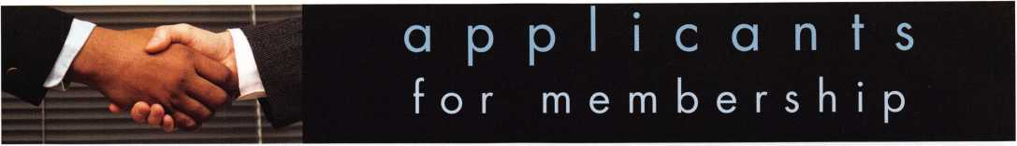

|  |  |  |  |  |  |  |
| --- | --- | --- | --- | --- | --- | --- |
| AL |  | GA | Peabody | NY |  | TX |

Birmingham Richard W. Waits

Sponsor: Robert J. McCormick CRL

Eureka Springs

Jeanette McDonald

Sponsor: John J. Ruperd Jonesboro

Britt Cooper

Apache Junction Chad M. Karabel

Sponsor: John A. Ilk CRL, CPS Mesa

Michael P. Casey

Phoenix

Daniel R. Johnson Jr

Sponsor: William Lee CRL

Los Alamitos

Gene Gednov

Tracy

Manuel Borba

Sponsor: George E. Phipps RL

Plainville

Greg L. Womack

Bourbonnais Steven G. Pugh

Sponsor: Michael G. Boisvert CML Calumet City

Wayne E. Merrick

Sponsor: Vincent Glispie CRL Chicago

Henry Greene

Sponsor: Vincent Glispie CRL Granite City

Larry M. Brooks

Sponsor: Kathy A. Zaniolo CPL Joliet

Robert Coleman

Sponsor: Robert W. Duman Sr, CML

Metropolis

Ed Hamm

Cheraw

Garvin O'Hare

Sponsor: Gordon R. Racine CML Colorado Springs

Eric Morgan

Longmont

David Yerger Trinidad

James McCoy

Ledyard

Robert Watrous Jr

Sponsor: J David Vessels CRL

Miami

Garry Bowman Middleburg

Bob Grace III

Sponsor: Vincent L Formon CML, CPS Tampa

Ed Jurewicz

Sponsor: Gary L Cooper

Hammond

Wendy R. Ostrander

Sponsor: Vincent Glispie CRL Indianapolis

Gloria J. Murff

Dodge City

Brent H. Whitaker

Sponsor: Elvis D. Hammerschmidt  
CPL

Olathe

Gregory J. Bovee

Sponsor: Rollin R. Gilliland CPL,  
CPS

Parsons

Stephen Passwater

Sponsor: Clifford D. Lipscomb  
CML, CPS

Amherst

Marcia A. Daniels

Boston

Michael Medice  
Cambridge  
David Burns  
Dorchester  
Eric N. Anderson  
Melrose  
Barbara Baker

William D. Whitney

Randolph Joseph Bukin

Sponsor: Barry McMenimon CRL Saugus

Thomas A. Lima Jr

Tyngsboro

Sally S. Marcheterre

Williamstown

David Jowett

Chesapeake Beach

Mark D. Lizzi

Glen Burnie

Gregory Boyer

Sponsor: Robbie Buss Hyattsville

Keith Howell

Rockville

Al Moran

Detroit

Kelvin L Heath

Sponsor: Dwayne S. Crenshaw CML Flint

Delano W. Barnes

Sponsor: James J. Belcher Livonia

Christorpher M. Sakhleh

Sponsor: David H. Vogel RL Redford

Virginia Smith

Sea brook

Robert J. Barry

Cliffside Park

Andrew Devoto Jr

Sponsor: Norman Parent

Guttenberg

Joseph N. Travelli

Holmdel

Anthony Chadwick

Sponsor: George Weickert III  
Marlton

Michael Bruder

Tije

Jay C. Dodge

Sponsor: Stephen W. Smith

Adams

Glenn Federman

Averill Park

Michael N. Fresina

Sponsor: Frank M. Commisso Bronx

Alfredo Hernandez

Barberton

Scott Teagle

Garfield Heights

Michael Schilk

Kent

Robert Batian

Trotwood

Scott E. Kilgore

Perry

Sam Ebersole

Sponsor: John J. Ruperd

Dundee

William Mulholland

Lancaster

Lisa D. Fogg-Evans

Philadelphia

Shannon M. Cropper

Sponsor: Robert C. Gress Sr, CPL

Winford Hayes Jr

Ceiba

Anthony Reyes

Sponsor: Alberto R. Gorbea SC

Florence

James Ard Jr

Sioux Falls

David E. Schmitz

Collierville

Patrick Hurley

Knoxville

Justin Nash John E. Simpson

Memphis

Jean Paul Cook

Sponsor: Danny R. Knight CRL

Dallas

Charlie Bradley

Longview

Ben C. Coulter CRL

Sponsor: Ralph O. Warren CML Nocona

Toby Booth

Logan

Tim E. Hansen CRL

Sponsor: Roger C. Yost CML, CPS Ogden

Nathan R. Smith

Sponsor: De\oy J. Flamblin CPL

Leesburg

David Popish

Sponsor: Aaron B. Greenburg

Karm Sandhu

Lorton

Steven D. Meade

Norfolk

Steven E. Jordan

Salem

Monique L Tinned

Four Lakes

Joel D. Anderson

Sponsor: Jane S. Anderson Kelso

James M. Hasty

Antigo

John T. Mills RL

Appleton

Jerrold G. Antoon RL, CPP

Shawano

John H. Campbell RL

Ireland

Mark Irwin

Rho-Milano Italy

Donatello Baracco

Sponsor: Luciano Fidani

Farnborough Hampshi

Martin Hutton

Plumstead London

Gordon L Ford

These applicants are scheduled for clearance as members of ALOA. The names are published for member review and comment within  
30 days of this Keynotes issue date, respectively, to ensure applicants meet standards of ALOA's Code of Ethics. Protests, if any, should  
be addressed to the Membership Department and must be signed. Active Membership applicants (a) have worked in the industry two or  
more years. Allied Membership (AL) applicants are not locksmiths, but work in a security-related field. Apprentice Membership (AP)

applicants have worked in the industry less than two years.



Keynotes • May 2003

JULY I JUNE MAY

u p c o m i

3 California Locksmiths Assoc. Trade Show and Education Ontario Convention Center Suzanne Harmony

714-632-6800 (see ad pg 31)



7 Ohio Valley Chapter of ALOA Membership Meeting 7pm Ryan's Steak House Middletown, OH (off exit 32) Mehdi Zahedi (937) 294-4241



4 Ohio Valley Chapter of ALOA Membership Meeting 7pm Ryan's Steak House Mehdi Zahedi (937) 294-4241



24 San Diego Chapter of ALOA/CLA

Membership Meeting 6:30pm Linda Vista Village Clubhouse Mike Perry (858) 967-9761



13

25

Greater Houston Locksmith Assoc Membership Meeting 7:30pm Judy Clifford (979) 297-2413 <http://ghla>. 1 cis.com/index.html

Pacific Locksmith Association Membership Meeting 6:30pm Denny's Restaurant Tualatin, OR Dan Cunningham 360-835-1191 [www.pla-pro.org](http://www.pla-pro.org)

15

n g

Fla. West Coast Locksmiths Assn. Monthly meeting 8:00pm Education: Paul Butler with MDS James Barnhardt [ernie28@ix.netcom.com](mailto:ernie28@ix.netcom.com)



The North Jersey Master Lock­smiths Association 9th Annual Flea Market • Lyndhurst NJ Jeff Sitan at 973-777-0620 or Mr. Lascar/Hart 201-944-7547

|  |  |
| --- | --- |
| 2 Ohio Valley Chapter of ALOA | 11-12 6th Annual American Lock |
| Membership Meeting 7pm | Collectors Association Lock Show |
| Middletown, OH | Cleveland, Ohio |
| Mehdi Zahedi (937) 294-4241 | Jon Kolozvary 440-243-2032 |

UPCOMING PRP SITTINGS

|  |  |
| --- | --- |
| 5/8/2003 | 8:00AM • Dallas, TX • ALOA  Janelle Ramirez 800/532-2562 X30 |
| 5/16/2003 | 6:00PM • St. Charles, MO  Bi-State Chapter  Kenneth Kim, CPL 314/351-7252 |
| 5/17/2003 | 5:00PM • Seattle, WA  KDL Hardware Supply, Inc.  Julie Pilgrim800/926-7716 or 206/682-7383 |
| 6/1/2003 | 8:30AM • Lewistown, MT  Montana Chapter of ALOA  Michael Alexander 406/549-5625 |
| 6/8/2003 | 9AM • Fairborn, OH  Ohio Valley Chapter  William M. Lockwood, CRL 937/836-6127 |
| 6/22/2003 | 1 PM • Farmington, NM  New Mexico L.A.  Deborah Pipkin 505/327-7500 |
| 6/12/2003 | 8:00AM • Dallas, TX • ALOA Janelle Ramirez 800/532-2562 X30 |
| 6/22/2003 | 8:00AM • Reno, NV  Clark Security Products  Joan Emrick 619/718-7308 |
| 7/10/2003 | 8:00AM • Dallas, TX • ALOA  Janelle Ramirez 800/532-2562 X30 |
| 7/19/2003 | 8:00AM • Las Vegas, NV • ALOA Janelle Ramirez 800/532-2562 X30 |
| 7/20/2003 | 8:00AM • Las Vegas, NV • ALOA Janelle Ramirez 800/532-2562 X30 |

|  |  |
| --- | --- |
| 8/7/2003 | 8:00AM • Dallas, TX • ALOA  Janelle Ramirez 800/532-2562 X30 |
| 8/17/2003 | 8AM • St. Pete, FL • SERLAC  Ken Kupferman 800/845-5294 |
| 9/11/2003 | 8:00AM • Dallas, TX • ALOA  Janelle Ramirez 800/532-2562 X30 |
| 9/21/2003 | 8:00AM • Anaheim, CA  Clark Security Products  Joan Emrick 619/718-7308 |
| 9/28/2003 | 8AM • Kansas City, MO Missouri-Kansas Locksmith Assn.  Greg N. Brandt, CML816/444-3233 |
| 10/9/2003 | 8:00AM • Dallas, TX • ALOA  Janelle Ramirez 800/532-2562 X30 |
| 10/18/2003 | 10:00AM • Chamblee, GA  GA Chapter of ALOA  John C. Elliott,Jr.,CML,CPS 770/314-7859 |
| 10/25/2003 | 9:00 AM • Sturbridge, MA  Yankee Security Convention  Jack Hobin 800/209-8266 |
| 10/26/2003 | 10AM • Mt. Laurel, NJ • G.P.L.A. Martin Arnold, CML 856/665-0464 |
| 11/13/2003 | 8:00AM • Dallas, TX • ALOA  Janelle Ramirez 800/532-2562 X30 |
| 12/11/2003 | 8:00AM • Dallas, TX • ALOA  Janelle Ramirez 800/532-2562 X30 |

UPCOMING ACE CLASSES

May 16-18

June 14

June 20-21

July 14-18

Sept. 20-21

Sept. 26-27

St Charles, MO • Bi-State Chapter Kenneth Kim, CRL, CPS 314/351-7252 Vancouver, BC (Canada)

BC Association Of Security Profsnls. Jerune Rodermond 604-607-6604 Farmington, NM • New Mexico Locksmiths Assn. Convention Deborah Pipkin 505-327-7500 Las Vegas, NV • ALOA David Lowell, CML, CMST 800/532-2562 xl8 (75 ALOA ACE Classes)

Syracuse, NY • Central New York Locksmith Association Ron Smith 315-782-0912 Casper, Wyoming Wyoming Locksmiths Assn Gene Ficek, CPL 605-6424542

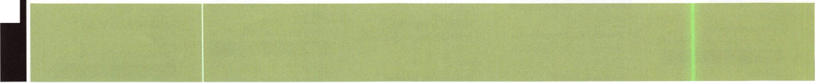

events

24 Greater Houston Locksmiths Assn. Interchangeable Cores Class Ed Stiles (979)323-9919

27 San Diego Chapter of ALOA/CLA Membership Meeting 6:30pm Linda Vista Village Clubhouse 2750 Wheatstone St., San Diego Mike Perry (858) 967-9761

28 Pacific Locksmith Association Membership Meeting 6:30pm Denny's Restaurant Tualatin, OR Dan Cunningham 360-835-1191 [www.pla-pro.org](http://www.pla-pro.org)

^•• ,y.y

New Product



SAFE CORPORATION

Viking Stainless

Fire & Burglary Protection  
State of the Art Composite Fill

Strong • Functional • Attractive

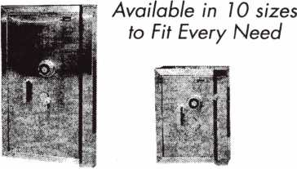

See us at [www.a-bsafecorp.com](http://www.a-bsafecorp.com)

1*-*800*-*253-1267

Fax 856-863-1208

CALL FOR YOUR CATALOG TODAY

**WHEN SERVICING**

**IN ERCHANGEABLE CORE PRODUC S,  
HAS I EVER SEEMED LIKE  
SOME HING WAS MISSING?**

**-CORE**

TM

**T-CORE™: “Real” thumbturns for Small Format Interchangeable  
Core (SFIC) cylinders, including Best®, Arrow™ and Falcon™.**

ALOA members please respond to recorded message.

Call toll free 1 (866) 839-6286

e-mail tcore@ev1 .net

Patent pending

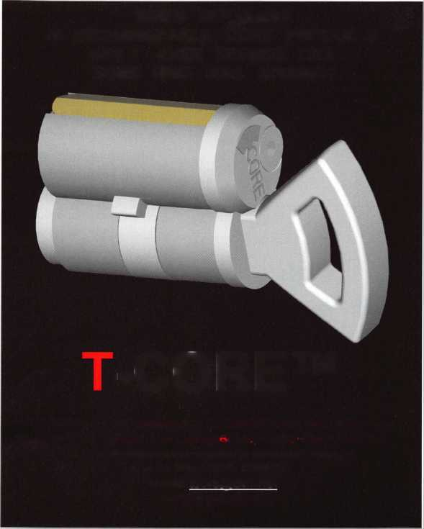

The Little Lock That Could

By Brian Costley, CML, CMST

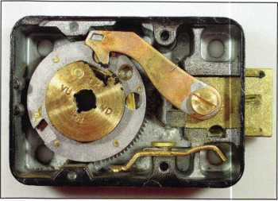

This is the 6730 that ran 160,986 cycles without a hitch. You might notice that the relock trigger has been bent away from the bolt. This was done to allow cycling with the cover removed.

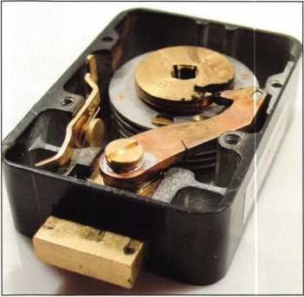

This angle clearrly shows the lubricant that migrat­ed to the drive cam and on to the lever nose. The dark color is due to fine particulates that are the natural result of wear.

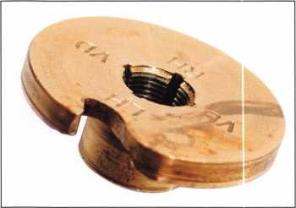

Once the drive cam has been cleaned up, it’s easy to see wear on the edge, where the lever nose rides.

I have no idea whether it “thought it could...thought it could,” but the little lock in S&G’s Test Lab definitely did it. The standard 6730 ran 160,986 cycles without a single failure. I was betting on 250,000 cycles, but the test was stopped because the dialing fix­ture was needed for another test, so well never know.

The test was ordered by the engineer of Sargent & Greenleaf’s R-Lock product line to see how well a new lubricant would affect the lock’s per­formance. In case you haven’t guessed, the results are considered nothing short of astounding. Prior to this exercise, we’d expect a 6730 to run somewhere between 40,000 and

1. cycles before the first failure. That may help to explain our excite­ment over what is usually a pretty mundane event; that and the fact that this is Nicholasville, KY, not New York or Chicago.

Before proceeding, let me explain a few things. First, a laboratory test is not meant to equate to real-world usage. A nice, clean environment and smooth, machine-controlled dialing cannot compare to what you’d find in a dusty, cramped convenience store office and the punishing dialing tech­niques exhibited by typical store man­agers. A lab dialing test is similar to what the lock would experience in testing by Underwriters Laboratories, VdS, or similar independent agencies.

You may be familiar with the item in U.L. Standard 768 that requires all Listed mechanical combination locks in any category (Group 2, 2M, 1, or iR) to run a minimum of 10,000 cycles without failure (and without service). Lock manufacturers will typi­cally engineer a lock to meet that specification, but not exceed it by



Keynotes • May 2003

much. Our testing of many different manufacturers’ locks over the years bears this out. There is, however, one notable exception.

The S&G 6730 differs from other Group 2 Listed locks in a couple important ways. It is designed with tighter dialing tolerances (a subject for another discussion), and it’s construct­ed to give three to four times more cycle life than other Group 2 locks.

Why the longer cycle life? The simple answer is that the 6730 is designed to hold up in situations where it is used many times every day. For instance, a few years ago, we documented that a particular safe located in a Chicago area McDonald’s is opened an average of 125 times a day. That is very, very high usage. If the life of a typical Group 2 lock is just over 10,000 cycles, the mechanism would be expected to last about three months before gasping its last breath. It won’t even make it to a reasonable sched­uled service date. In this same envi­ronment, a lifespan of a little over

1. cycles gets us close to a year’s worth of unserviced operation. This is much more acceptable to a typical safe owner. OK, that’s the explanation of why a 6730 typically runs for something between 40,000 and
2. cycles.

A critical factor in the lock’s lifespan is lubrication. For many years, Sargent & Greenleaf used and recommended General Electric’s G322L Versilube paste This is a silicone, soap-thick­ened grease based on methylalkyl polysiloxane fluids. It’s a paste of medium consistency, light pink or yel­low in color, and it performs well in a combination lock. I always liked it because it is easy to apply in a thin film and is just thick enough that it

resists migrating to areas in the lock other than where it was deliberately applied. When this unwanted move­ment occurs, we refer to it as “creep.”

A couple of years ago, I received a new tube of Versilube in a shipping box that contained one of those infa­mous tags that reads, “This product contains substances known to the State of California to cause cancer in laboratory animals.” That’s comforting to know after 30 years of lubricating combination locks with it. A quick inspection of the Versilube Safety Data Sheet says the paste may cause mild skin irritation, and that it “con­tains hexavalent chromium com­pounds which are listed as chemical carcinogens.” It doesn’t say how many pounds of the stuff must typically be injected into a major artery before symptoms appear.

General Electric sold Versilube to a company named Novagard about four years ago. This caused a minor panic among safe technicians at the time.

It was feared that Versilube, a favorite safeman’s lubricant, would disappear. However, Novagard continues to dis­tribute the product from its Cleveland, OH, facilities.

Just about 10 years ago, S&G began using Dow Corning Gn Metal Assembly Paste in all 8400 and 8500 series Group 1 and iR combination locks. This is a multi-purpose, heavy duty lubricating paste consisting of a blend of molybdenum disulfide and white solid lubricants in mineral oil.

It is a lighter consistency than Novagard’s Versilube, and dark gray to black in color. It was originally adopt­ed by S&G for use in combination locks because it does not break down readily at high temperatures.

In the early part of the last decade, S&G Group iR locks were required to pass a military performance test referred to as the “8-hour, 600 RPM Test.” It’s not too difficult to figure out what this entailed. The lock’s dial

was spun at 600 RPM for a period of 8 hours. Originally, the specification said that the lock must remain secure after the 8-hour period. This was not a problem, since the inside of the lock was pretty ugly after this blender-like experience. Then the rules were changed to say that the lock must remain secure after the 8-hour ordeal, and that it must open on the set com­bination. That last little phrase makes a world of difference, and was the rea­son Gn Metal Paste began to be used in S&G locks. Its resistance to high temperatures generated inside the lock case during the test kept the lock operational.

Over the next several years, Gn Metal Assembly Paste gradually replaced Versilube in all S&G mechanical safe locks, except for vault locks. It is a high quality lubricant, but I never liked it as well as Versilube for real- world service. Its thin consistency encourages creep, a condition aggra­vated by the fact that S&G tends to over-lubricate its locks at the factory I could not find a Safety Data sheet for Gn Metal Paste, but I can tell you the reason S&G went looking for a new lubricant stemmed from factory workers’ complaints that they experi­enced skin rashes thought to be caused by the paste.

This brings us to the Aeroshell 22, the latest lubricant officially blessed by S&G. Aeroshell 22 was used in the 6730 lock that ran 160,986 consecu­tive cycles in our laboratory With Versilube or Gn Metal Paste, we’d expect the typical 40,000 to 50,000 cycle lifespan. Based only on this test, it appears that the Shell product, a synthetic oil grease thickened with clay and containing molybdenum disulphide and additives, has superior lubricating qualities in mechanical combination locks. The Aeroshell Safety Data Sheet tells us that it “may cause sensitization by skin contact. Prolonged or repeated exposure may give rise to dermatitis.” It advises min-

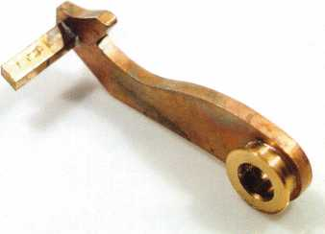

Like the edge of the drive cam, the lever nose shows wear. The tip of the lever doesn’t start out with that small flat spot on it.

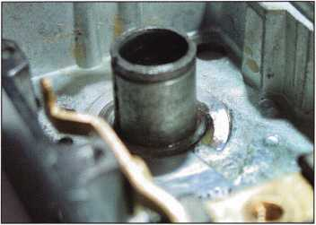

The wheels are removed and the wheelpost cleaned up. No wear is obvious on the outside of the wheelpost even though the wheels made somewhere in the neighborhood of 2,225,000 rev­olutions around it.

Note the excess lubricant that is still apparent at the base of the wheelpost and at the back of the lock case.

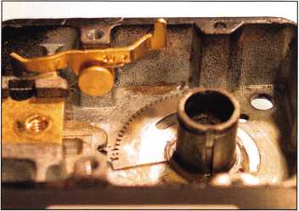

A very small amount of powdered metal debris (looks like brass) has collected at what was the bottom of the lock case.

Keynotes • May 2003

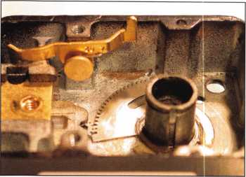

A very small amount of powdered metal debris (looks like brass) has collected at what was the bottom of the lock case.

There are three pertinent points to keep in

mind when considering combination lock

lubrication:

1. It’s important for the lock case and com­ponents to be clean before they are lubri­cated. Most often, thorough cleaning can be accomplished with nothing more than a clean, lint-free cloth. When stronger measures are required, give a lot of thought to replacing the lock. If the lock is full of caked-on grime, it’s a safe bet that particulates embedded in the old grease have partially chewed up components over time. Once this happens, even clean­ing and proper lubrication won’t produce satisfactory results. If you want to proceed with cleaning, use mineral spirits, or any non-corrosive cleaning agent that does not leave a residue of its own. Do not use any cleaning agents on plastic parts. This shouldn’t be an issue with 6730s, with the exception of those made in the early to mid 1980s. These use SecureMax wheels made of plastic. The good news is that few of these locks are around today. If you run into one, I’d definitely recommend replacement. At the very least, you should replace the plastic wheel pack with a metal one.
2. In any lock, lubrication should be restrict­ed to specified points. There are places in a lock where even the correct lubricant will do more harm than good. For instance, lubricating the machined brass flies of a 6730 may well cause these very lightweight parts to stick in the wheel cen­ter’s raceway. They need to move freely for the lock to function properly, and this is one part that works best with no lubrica­tion.
3. Whenever you are applying lubricant inside a lock case, use only a very thin, almost invisible film. As one of our engi­neers likes to say, “Anything over two mol­ecules in thickness is a waste.”

It’s a slight exaggeration that makes a good point.

imizing all forms of skin contact, and says “Wash hands before eating, drinking, smoking, and using the toilet.” Ouch! That’s an attention-getter, eh?

I guess this stuff won’t be showing up on any of Dr. Ruth’s recommended accessories lists. On the bright (and more serious) side, the publication goes on to say “Components are not known to be associated with carcino­genic effects.”

Aeroshell 22 has a consistency and yel­lowish appearance much like Versilube, and exhibits extraordinary lubricating qualities when used in mechanical com­bination locks. It looks like a solid win­ner. There are a couple of comments, however, that are necessary.

Like most mechanical locks coming out of S&G, the 6730 that appears in this article was over-lubricated by field serv­ice standards. In other words, there is significantly more Aeroshell 22 in this lock than I would allow you to use in a servicing class. Some of this grease migrated out to the edge of the drive cam, which probably further extended the useful lifespan of the lock.

Remember a lock called the Scrambler? It was produced in the early 1990s, and one of the challenges it presented was keeping the lever nose and drive cam from eating each other up. The Scrambler used a strong lever spring, and the increased friction it created between the lever nose and drive cam greatly accelerated wear on both compo­nents. Eventually, a hard chrome coating was put on both the lever nose and the outside edge of the drive cam to allevi­ate wear. There was another alternative that worked just as well, however.

It consisted of a thin film of Versilube applied to the lever nose and drive cam edge where they rubbed against each other during normal dialing. The con­



Keynotes • May 2003

cept of simply specifying this as a lube point was abandoned in light of the fact that it would be the lock installer’s responsibility to apply the grease in the correct places and in the correct amounts. In other words, we really did­n’t believe the grease would be applied often, if ever.

The story should cause a light bulb to illuminate somewhere in your head. Want to increase lock life in heavy usage environments? It helps to put a thin film of the proper lubricant on the lever nose and edge of the drive cam, where they rub against each other.

It’s seems appropriate to cover lock lubrication points as long as we’re talk­ing about different flavors of grease.

Did I ever tell you about the time a safe owner called me to complain that his safe had stopped working only a week after he’d thoroughly lubricated the lock? “Yeah, I was having some trouble gettin’ the lock to open every time, so I took the inside cover off the door and found a hole in the back of the lock where you lube it.” Silly me — I had always thought this was a change key hole, used just for combination chang­ing. It took an astute end user to point out to me that this was actually a pri­mary lubrication point for the lock.

“I stuck my WD40 nozzle in there and sprayed til it was runnin’ back out the hole. It worked real slick for a week or so, but now I can’t get the safe open at all. What’s wrong with your lock?”

It’s best to stop quoting the customer at this point, since my shorthand explana­tion of what led to the failure elicited comments you wouldn’t want to have to explain to your children if they hap­pened to see Keynotes open to this page on your workbench. Know what I mean?

Any of the three lubricants referenced in this article are acceptable to the manufacturer. No other lubricants should be used. That doesn’t mean that there aren’t some really great lubricants out there. It means that only grease S&G has tested with its products is acceptable to S&G. A note of caution: If you return a lock to Sargent & Greenleaf under warranty and it contains a lubricant other than Versilube, Gn Metal Assembly Paste, or Aeroshell 22, expect the claim to be denied.

As Forrest says, “And that’s all I have to say about that.” As Nicholasville’s Aeroshell 22 Festival fades into exhaustion (all the dancing wreaks havoc on my knees), we leave you with all the knowledge necessary to select the proper lubricant and apply it in just the right places on your future servicing jobs. Now don’t for­get to use a new spline key and set the wheelpack torque at the high end of its specified range, reset the combina­tion and balance the dialing tolerance, brush your teeth and say your prayers.

6730 Lubrication Points

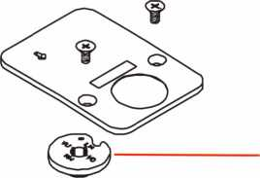

(optional) outside surface of the drive cam

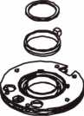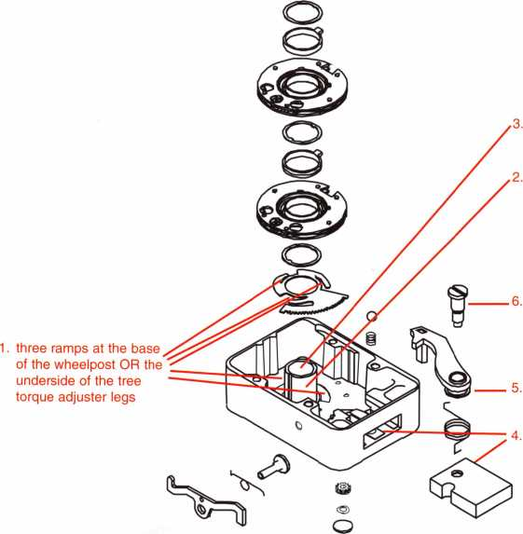

inside surface of the wheelpost

outside surface of the wheelpost

bearing surface of the lever screw

underside of the lever bushing

the bearing surfaces of the boltway OR the surfaces of the bolt that bear against the case

Keeping the last two points firmly in mind,

here are the manufacturer’s recommended

lubrication points for the S&G 6730 lock:

1. At the base of the wheelpost, there are three ramps that accommodate the legs of the torque adjuster. Apply a thin film of lubricant to the ramps OR to the under­side of the torque adjuster legs.
2. Apply a thin film of lubricant to the outside of the wheelpost, where the wheels rotate on it.
3. Apply a thin film of lubricant to the inside of the wheel post, where the neck of the drive cam rotates within it.
4. Apply a thin film of lubricant to the sur­faces of the case’s boltway, where the lock bolt slides against it OR to the sur­faces of the bolt that will slide against the case.
5. Apply a thin film of lubricant to the under­side of the lever bushing where it pivots against the top of the lock bolt. This is not a point lubricated at the factory, but is rec­ommended for servicing.
6. Apply a thin film of lubricant to the bearing surface of the lever screw where it con­tacts the inside of the lever bushing.

Again, this is not point lubricated at the factory, but is recommended for servicing.

1. At your discretion, depending on the envi­ronment and expected usage of the lock, you could apply a very light film of lubri­cant to the outside edge of the drive cam, where the lever nose rides on it.
2. Although not a required lubrication point,

I like to put a very small dab of grease on the underside of the dial hub where it will contact the dial ring bearing. Since we’re outside the lock case, a small dab is OK. Sometimes a dial will squeak when turned. This doesn’t indicate any problem, but it is annoying, and a small amount of grease will alleviate it. Note that some petroleum-based greases can break down the material of the dial ring bearing. If you stick with Versilube, Gn Metal Paste, or Aeroshell 22, you don’t have to worry about this.

Keynotes • May 2003

ALOA Complaint Form

The proposed “The Motor Vehicle Owner's Right to Repair Act” ensures the right of a motor vehicle owner to obtain all information required for the diagnosis, service, and repair of the motor vehicle in a timely, affordable, and reliable manner. Although the bill does not specifically say what information must be pro­vided, ALOA is working with the after-market industry to ensure that the information you need to service any vehicle is released. This complaint form provides ALOA with information that will identify any prob­lems locksmiths may encounter through servicing their customers during a vehicle lockout/re-keying/originat­ing keys incident. We will use this information to make our case to the automobile manufacturers and to Congress on why this bill is important to locksmiths.

Locksmith Name:ALOA#

Shop Name:

Date/Time Received Customer Call:

Customer Name: Phone:

Vehicle Manufacturer: Type:Year:

Briefly describe incident, of why you were unable to service the customer, including any inconvenience the customer experienced:

Return completed form by mail or fax to: ALOA

3003 Live Oak St.

Dallas, TX 75204 Fax: (214) 827-1810 (make copies as needed)



CCTV Content

**14 hours**

CCTV Calculators

Demonstration Tool

Estimation

Drawing

Internet Enabled

Knowledge Assessment

***Visit our Website on www. stamcctv. com***

THE COMPLETE

CCTV PROGRAM ON CD-ROM

FOR STAFF TRAINING AND

PRODUCTIVITY ENHANCEME

1# System Drawing

41 Estimation

44 CCTV Training

**44** CCTV Reference

I# Sales/Demo

4# System Design

4# Staff Evaluation

STAM **Insight** has been developed to enhance CCTV skills and productivity with many different uses.

**44** Productivity

**Sold in Over 50 Countries**

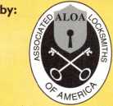

3003 Live Oak Street  
Dallas,Texas 75204

■ Yes, please send me a FREE PREVIEW CD ROM $9.95 S/H

Name:

Job Title:

Organization:

Address:

Zip/Postcode

Country e-mail

Tel: ( ) Fax: ( )

**COPYRIGHT © 1996 Security Training and Marketing Pty Ltd. All rights reserved ACN 057 006 541**

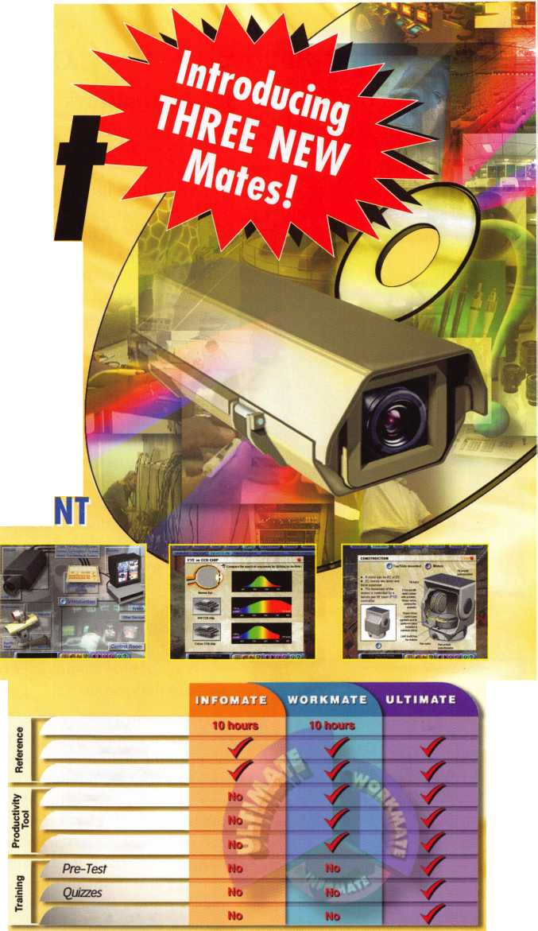

Don’t Judge a Safe by its Cover:

What it says on the outside is not always what's on the inside! By Greg Perry CML, CPS

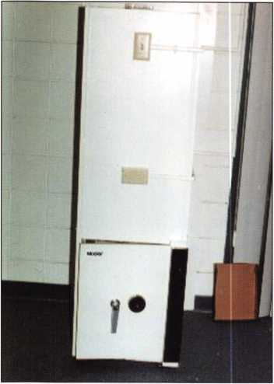

Inside view of the overall night depository.

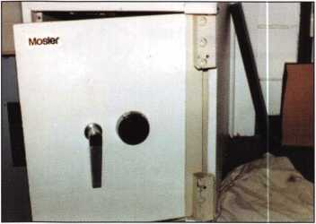

Close up of door

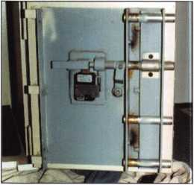

Inside view of door

Sometimes, just because a safe claims a certain parentage doesn't mean the label is correct. When a manufacturer has a need for a safe they don't cur­rently produce, they may buy it from a competitor and put their own label on it. Or, as they buy up the competition, they may continue to produce safes using the bought up company's designs, but put their label on the safes. This was the case with a safe labeled "Mosler" with a Mosler CDK- 302 key change lock, but built in the Hermann safe factory after Mosler purchased them. Hermann Safe com­pany was founded in the late 1880s and was sold to Mosler in the late 1960s. Mosler continued to produce safes using the Hermann designs in the Hermann factory for several years. Mosler has since closed up operations completely, filing for bankruptcy in August 2001. Diebold purchased their assets about nine months later from the bankruptcy court.

A call came in a few years ago from a local credit union claiming they could­n't open the night drop. A curious call, since this credit union has always used our competitor claiming, "You're too high priced!" The competition had changed the combination a month or so earlier. It had worked fine, but now it wouldn't open. Did they perform a service or disassemble the lock and not put something back correctly? Is this a hand change or key change lock? I asked the manager if she watched him, did he take anything apart? She seemed to think he just stuck a tool in the lock to change the combination. Did his lack of service contribute to the lockout? The safe had been locked for three days and our competition had given up. The safe was uncompromised. Fortunately,

no attempt was made to penetrate the container; I don't believe our compe­tition has a drill rig. My boss and I had both shown up to look at the safe. We were given the combination to try We checked each number for slippage by dialing each number over and under. Neither of us could feel a strong wheel pick up. The number 2 wheel was especially weak. Time to drill; the only question was, where? At this point, we did not know which lock was inside. Mosler produced both a CD-120 and a CD-302 lock that used this same dial. From the outside, it's impossible to tell the difference. Was the unit a TL15 or a C rate? If I side drilled, how far back did I need to drill and how was the lock handed? The general rule (with few exceptions) is the lock bolt points toward the han­dle. I looked through my library and found nothing under Mosler. I called Mike Oehlert at SAVTA for advice; he suggested calling Maurice Jones at Mosler. Maurice knowing more about Mosler safes than perhaps anyone else in the world was not familiar with the safe as I described it. The hinge cover was narrower than anything he recalled. He sent me a fax of a door that was of similar size, and it was close, but not the same. I called him back with the serial number. He researched the number to find it was indeed made in the Hermann factory after Mosler purchased Hermann Safe Company. Sorry he could not identify it more, no hand or rating. His guess was that it probably would be a CD- 302 mounted VU, not pointing toward the handle this time. I checked my Hermann info and did not find any­thing like it.

Armed with this info and not getting any younger, I decided to side drill 1

**16**

Keynotes • May 2003



1/2" back from the face of the door on the hinge side in line with the lock case to get a look inside the lock case. Side drilling has several advantages. You miss the hardplate and can drill a larger hole much more easily. This can allow you to move the tip of a smaller drill bit around inside the door with­out needing to drill a second hole through the outer surface. My goal was to enter the lock case beside the fence. This should allow me a great view of the wheel pack. I didn't want to attempt a frontal attack until I could identify the lock and only if a side attack failed. My first hole missed the mark. The bit entered into the area behind the lever obstructing the view of the wheel pack. I moved the hole up and back a little, still not far enough back to get a scope inside the case. I drilled into the lever slightly so I could get a scope inside. Once inside, I could see the reason for the light feel on the number 2 wheel. It was not moving; wheels one and three were moving, but wheel number two didn't move. The change hub was open or broken, allowing the outer portion of the wheel to just spin.

What should be the next step? My hole would not allow me to probe the number 2 wheel around to drop-in. At this point, I was also able to identify the lock as a CD-302, meaning we now know where to drill from the front, should it become necessary.

This would mean destroying the dial and another hole, this time through hardplate. My next choice instead of drilling a new hole through the con­tainer wall was to use the existing hole and maneuver the tip of the drill bit over to drill a new hole through the case. My goal was to drill the fence off from the side.

I've worked on hundreds of MR-302 locks; this was the first non-manipula­tion resistant or CD-302 lock on which I've worked. My understanding was the difference was in the drive cam. The MR-302 (hand change) and it's companion MRK-302 (key change) used a split drive cam. The lock case

has a ball bearing that snags or drags the lower portion of the drive cam to open it momentarily to allow the fence to drop. It creates a click-click or ratchet in the area of zero; a CD- 302 will not. Otherwise, the locks are the same, or so I believed.

I now aimed the drill bit for the area of the fence. I hoped to drill into the side of it, effectively removing it. This would allow the lever nose to drop in to the drive cam gate and retract the bolt. After drilling through the case, I hit the fence and the bit snagged or grabbed. All the MR-302 locks I've seen use a brass fence. This lock had a fence made of a different material. Looking through the scope I could not determine what that material was, but it was hard. I finally used a punch to break it off. After getting the safe opened, I found Mosler used a roll pin as the fence. Removing the lock con­firmed my diagnosis; the number 2 wheel change hub was open, allowing the wheel to spin free. I welded the holes and used some of their paint to hide the repair. A freshly serviced MR-302 lock was installed.

I am still not sure if the lack of a serv­ice the month before contributed to the lockout. It's possible that during disassembly our competitor should have caught a loose change hub. Or perhaps the hub was partially open before they started, and that a proper service would have caught this. Another possibility is they used the wrong change key or a home made key to perform the combination change. We'll never know the real answer.

This safe was a challenge to open, not having the correct information con­tributed to the length of time it took to open it. Being sent on a chase of information for a Mosler safe - when, in reality, the safe was a Hermann — also contributed greatly to length of time it took to open the safe. Remember: When it comes to safes, what it says on the outside is not always what you'll find on the inside.

A view of the inside of the door showing the mounting of the lock, relocker and bolt work.

The cam on the left is the MR-302 drive cam. The  
lower half is only open for a brief moment as the  
ball-bearing detent grabs the lower half momen-  
tarily. The cam on the right is the CD-302 drive  
cam. It is similar to most other group 2 type locks.

A view from inside the lock body. You can see my  
three holes. The first one is seen in the lower  
right. This is the hole I used to drill partially into  
the lever. The second hole was not useable. It was  
also too low to be used to probe the Number 2  
Wheel or drill off the fence. The third hole is just  
above the fence. It was this hole I used to first  
attempt to drill the fence off before finally using a  
punch to remove the roll-pin fence.

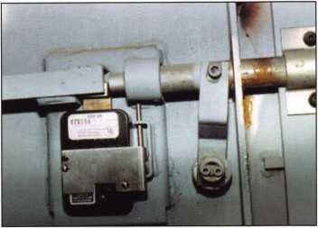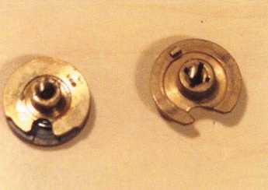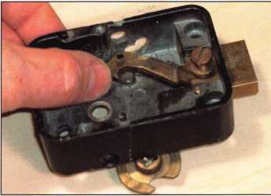

Keynotes • May 2003



The Call Came In Like This

SAFETECH Participant Crosses the country twice during San Diego show to open a vault in New Jersey

By Kenny Hiemstra Jr.

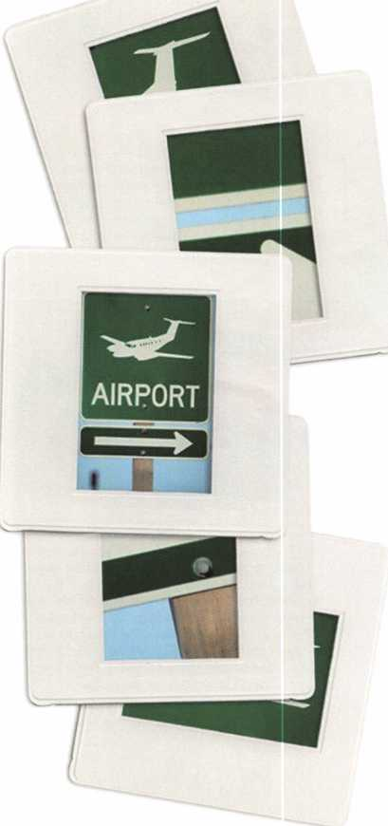

While I was teaching professional safe opening  
with Ron Jewel on the second day of classes at  
this year's SAFETECH show in San Diego, my  
cell phone was ringing off the hook. During the  
break, I checked my voicemail and was told my  
services were greatly needed to open a bank vault  
in my home state of New Jersey. The cause of the  
lockout was a time lock malfunction and only by  
proper diagnostics and precision drilling can this  
bypass method be accomplished through the face  
of the door.

The bank needed the door open ASAP. The vault  
was loaded with safe deposit boxes and all the  
bank's working cash. The alternative to going  
through the door was to core drill the wall. This  
method is messy and can take days for the repair  
to be completed. Even once it is completed, the  
"soft patch" wall repair makes for a weak point in  
the vault perimeter, because the concrete used to  
make the wall repair is not up to the high pounds  
per square inch (psi) rating that the vault was  
originally intended to have. The bank insisted on  
a specialist to come in and open their door,  
because they wanted their door opened in the

**8**

Keynotes • May 2003

most professional manner. Being that the handful  
of people who can do the job are all at the annual  
SAVTA convention, my services were needed.

While teaching the class, I had a fellow SAVTA  
friend set up my flight, and I took the redeye  
back to N.J. Landing at 6 a.m. I went to the shop  
and loaded up all my equipment to open the  
door. I arrived at the bank and diagnosed the  
problem. After deducting my drill point, I set up  
to drill the door open. After several hours and  
needing an 18-inch drill bit to reach my target,

I was able to defeat the problem and swing the  
door open. I then cleaned up all my tools an  
made the undetectable repair on the door to  
bring them back into service. The end result  
was one happy branch manager and one tired  
safe technician.

I then went home, unpacked my tools and  
packed my clothes to catch that Thursday morn-  
ing's early flight back to the SAVTA convention.

I arrived back in San Diego mid afternoon on  
Thursday and was able to enjoy the rest of the  
convention and the sunny California weather.

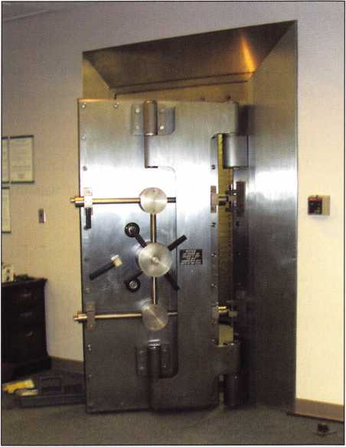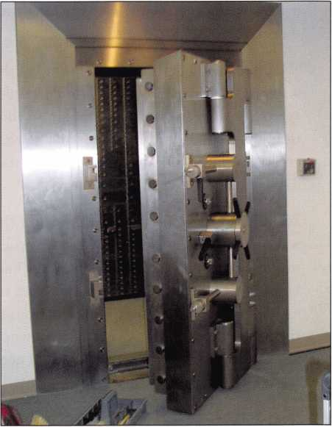

Keynotes • May 2003

Solving a Vault Lockout

By Merritt Perkins, RL

A woman called me on the telephone for help because she could not open the vault in her store building. The vault and her business were on the first floor and she was living on the second floor.

The vault was installed when the building was remodeled, about 1920. The vault was intended to store records.

I went to look the situation over and did not take any tools with me. From the name on the dial,

I could see that it was a Seargent & Greenleaf lock. The dial turned smoothly but I did not feel the tip of the lever contacting the drop in of the drive cam. If you dialed the correct combination, it would not unlock. There was no use to try manipulation.

The owner had called another locksmith and he had tried to open the vault without success. She said that he had oiled the lock when he worked on it a few years ago. While I was talking with the owner, the other locksmith arrived.

We discussed the situation and decided that any attempt to drill into the door would result in dam­age that was very difficult to repair, so the best solu­tion was to make a hole in the vault so that we could get in to work on the lock. This would not damage the door, or the lock.

We did not know how thick the wall of the vault was, what it was made of, or what obstructions were inside. Some old vaults had brick walls lined with heavy steel plates riveted together. If we tried to cut a hole in the wall to enter the vault from the side the hole would be unsightly and the owner would not want the public to see it. It would need to be repaired promptly.

The vault was about eight feet square and eight feet high and the ceiling of the room was about 11 feet high. A light wood door above the vault door gave access to space over the vault.

The owner brought in a six-foot stepladder.

I climbed up and looked at the top of the vault. There was a hole about 1 inch in diameter just behind the vault door through which I could look down inside the vault. A switch outside the vault controlled a light which illuminated the inside of the vault. The top of the vault was concrete, and about 1-1/2 inches thick. I could see the back of the vault door and the lock. The lock was a hand change combination lock, so the curb with the wheel pack could be easily removed. The bolt work on the inside of the door was exposed.

It seemed that the best procedure was to make a hole in the top of the vault behind the vault door so that a person could climb down. After discussing how to do this, the other locksmith went to get some tools.

The other locksmith came back with a hammer drill that had a 1/2-inch carbide masonry bit. You need to use a hammer drill with a carbide bit because with an ordinary electric drill you just wear out the bit and don’t cut very much. Another way to drill con­crete is with a star drill and hammer. You turn the drill a little after each hammer blow. When you cut metal, plastic, or wood, the sharp cutting edge of the drill is forced into the material and bends the cuttings aside. Concrete is very brittle and you drill it by breaking it into small pieces.

20

Keynotes • May 2003

I started drilling about eight inches inside the front of the vault and found that there was steel reinforcing mesh in the middle of the concrete about one inch square made of rods about 5/32 by 3/32 inches. Once we had a hole through the concrete we let the cut­tings fall to the floor of the vault.

We took turns drilling until we had drilled out the cement about 3/4 inch wide around a rectangle about 24 by 14 inches. I had learned from experience that you need to make the hole plenty big enough so that you don’t have to enlarge it later.

This was slow work and took two or three hours.

Then we had to cut the reinforcing mesh and lift out the piece that we had cut loose. We cut reinforcing mesh with a hacksaw blade with a rag wrapped around it for a handle. You need a fine tooth blade.

It would have been much easier if we had some kind of cutting pliers.

The cut-off ends of the mesh were sharp and we bent them back with pliers. It helps to cover the sides of the hole with corrugated cardboard. Climbing down through the hole is difficult enough and you need to do everything that you can to make it as easy as possible.

We cleared away the extension cords and tools.

The owner’s friend volunteered to climb down inside the vault.

He was smaller and more agile than the rest of us.

I handed him the 1/8-inch screwdriver that I carry In my shirt pocket and a pair of gloves that I had in my hip pocket.

He climbed down inside the vault, and following my instructions, removed the 6-32 flathead machine screw, turned the curb about 1/8-turn counterclock­wise and lifted it out of the lock.

I moved the stepladder aside, turned the dial to unlock the lock, turned the handle to withdraw the bolts, and swung the door open.

The owner said that she could get someone to cover the hole with a piece of plywood. The right way to repair it is to use a post jack to hold a piece of ply­wood or steel plate under the opening tight against the ceiling, put the cut out piece back in place, bend the cut off pieces of reinforcing mesh so that they come together, and weld them, which can be done with an acetylene torch. Then the space can be filled in with concrete and allowed to set, and the supports removed. Coat the plywood or steel plate with paste wax so that the concrete will not stick to it.

The owner’s friend said he had some very good oil that we could use to oil the lock.

What was wrong with the lock? THE LOCK HAD BEEN OILED! With age, the oil tends to get gummy and collect dust. This makes it difficult to turn the dial smoothly to the exact number. The lever may hang up and not drop down into the drop in of the drive cam. If the wheels have flies, a fly may stick and cause the wheel to be turned too far.

A combination lock may be opened several times a day or weeks may go by when it’s not used. The lock will work without lubrication. See the article on page 10 regarding lubrication of safe locks.

**21**

Keynotes • May 2003

Keynotes • May 2003

Is Investigative Locksmithing

in VoUf Futnte? By: Claire L. Cohen, CML

Before he died, one of former ALOA Board Director Jim Glazer's dreams was to form a group who could work together to further professional knowledge in investigative locksmithing. He envisioned a joining together of lock­smiths, security professionals, police officers and insurance investigators with a common interest in investigative lock­smithing. With Jim's vision, informal meetings were held between a small, interested group, which included Donald Shiles, RL, CFL (current President) and Leonard Podgorski, CFL (current Vice President). The group began discussing ideas and setting goals. Jim enthusiastically start­ed some preliminary paperwork. In 1998, Jim's dream became a reality with the formation of The International Association of Investigative Locksmiths (IAIL).

If Jim could be here today, he would see IAIL members involved in developing investigative locksmithing as a pro­fession. With almost 500 members, they strive to learn more about this field, and help share that knowledge with others. News of the association has spread, and now mem­bers come from all over the United States, Canada and Europe. Members receive a quarterly newsletter (IAIL Journal), loaded with tips and techniques. Association members are encouraged to network with others through meetings, the IAILs annual convention and e-mail. They have recently published a training book (available on CD) with basic information and color photos on how to analyze locks, pin attack, and more.

Members of the association feel that the investigative lock­smith can offer a service to the community and to the law enforcement professionals. Investigative locksmithing, (according to association members), at present is being offered only sporadically. IAIL members are committed to offer technical, professional advice, council and investiga­tive services to the community, insurance companies, and law enforcement officials.

The association has been recognized in U.S. courts, by major insurance companies, almost every national law enforcement agency, Canadian law enforcement agencies, as well as many state police and local police departments.

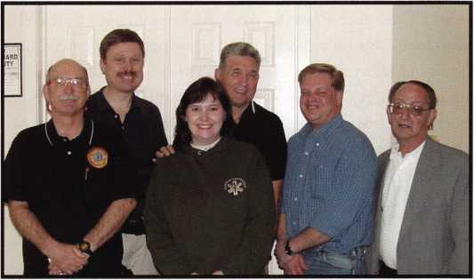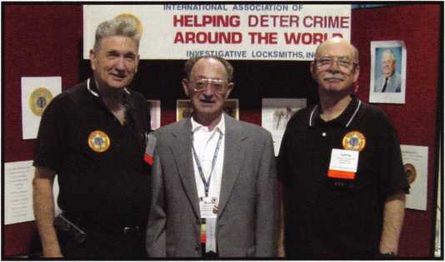

They have received requests for information and/or training from many different police organizations around the world.

Insurance companies and police departments contact IAIL for referrals of expert witnesses, or documented opinion. Some IAIL members, with unique skills and documented areas of expertise, have been asked to assist in investiga­tions. One member was asked by an insurance agency to investigate a stolen car. The car had been located, but it had been burned in a fire. The insurance investigator felt that this may not have been a routine stolen car case. The investigative locksmith was called in to help. Upon further examination, it was concluded that the proper key had been used, and the fire was used to attempt to destroy the evidence! D.C. police asked for help in investigation of a death of an unidentified person. Beneath the body, a ring of keys was found. An IAIL member was called in to aid in

Keynotes • May 2003

the investigation. Upon examining the keys, the locksmith told police that one of the keys was a registered key Helping the police contact the lock manufacturer, they were able to come closer to identification of the body.

IAIL member, Rich Pacheco, was asked to investigate a stolen car insurance claim. The locked car was located on a hillside, 300 feet from the road. Rich used ropes to traverse the slope. Not only did he find the suspect's stolen car, but he found many other stolen cars! The hillside had been used as a dumping ground for stolen vehicles. VIN num­bers were provided to police to aid owner identification of the vehicles. Our locksmith had an extra-added surprise when he unlocked one of vehicles and opened the door- rattlesnakes crawled out!

In Maryland, a female social worker was charged in the sex­ual assault of a 15-year old boy she was visiting at a juvenile detention center. The social worker claimed that she was the victim in the case, and that the troubled teen raped her in a locked meeting room. This could have carried a 10- year prison sentence for her. She told police that while try­ing to escape an attack, she was unable to open the door. Donald Shiles, CFL, was called to help in the investigation. He attempted to simulate which steps a frightened person might have taken to escape an attack. He ascertained that the lock had failed. He was able to testify why the lock malfunctioned. As a result, the social worker was acquitted.

Donald Shiles has been called several times to serve as a technical advisor for both the CSI-Las Vegas and CSI- Miami television show on questions concerning locks and security devices.

A goal of the association is to improve the safety and secu­rity of the public through seminars, meetings. As an exam­ple, their website ([www.IAIL.org](http://www.IAIL.org)) offers home and business security tests.

The Association has developed a certification program, which will lead to the designation of CFL (Certified Forensic Locksmith). This designation is awarded upon completion of certain relevant classes, which are offered by both ALOA and IAIL. To date, there are 30 Certified Forensic Locksmiths. Applicants must have been a member of IAIL for a period of at least one year prior to applying to take this examination. The examination consists of a written examination and an oral examination. In addition, each applicant must agree to a full criminal history records check. (More information on this can be obtained by con­tacting IAIL).

The Association teaches classes not only to its members, but to other association as well as law enforcement offi­cials, insurance investigators, and others who qualify and have been approved by IAIL. Highlights of some of the classes include:

* Introduction to Investigative Locksmithing, which includes instruction in crime scene searches, preserva­tion of evidence, documentation of the scene, and more. It includes techniques in effectively working with law enforcement officials and insurance investiga­tors.
* Hands-on training with basic tool kits, microscopes, and various pins and wafers to identification tech­niques.
* Qualification techniques as an expert witness with emphasis on how to prepare for a trial and building a business as a Forensic Locksmith.
* Auto Theft, Arson and Forensic Examinations, includ­ing theft techniques, and recovering lock components from burned vehicles.

This year, IAIL plans on teaching at many conventions, including Auto Theft, Arson & Forensic Examinations instructed by Ken Vitty CFL, at the MLANJ Convention, and Investigative Automotive Locksmithing instructed by Bruce Sumner, CFL, at SERLAC 2003. Also scheduled are classes in Alberta, Canada and in Maryland.

IAIEs first convention was held last year in New Jersey. About 50 members attended various sponsored activities, including classes in which hands-on techniques were demonstrated. This year's convention promises to be even better, and a great learning experience. It is scheduled for August 28 - 31, 2003, in Mount Laurel, NJ (a short drive from the Philadelphia Airport). Classes will be available in all aspects of forensic locksmithing, fire investigations, etc. Outstanding instructors from all over the United States will be at this meeting. Tentative classes include: ByPass Techniques, Forensic Locksmithing, Investigative Locksmithing III, Preparing for Court Appearances and writing CV's, Forensic Photography, Metallurgy, and Conducting Vehicle Exams.

Is investigative locksmithing in your future? For more information on becoming a member of The International Association of Investigative Locksmiths, or attending their Convention in August 2003, Visit IAIL website: [www.iail.org](http://www.iail.org). Contact IAIL: 1507 WHITMARSH CIR, SEVERN, MD 21144

**24**

Keynotes • May 2003



**RING of a KING**

|  |  |  |  |
| --- | --- | --- | --- |
| Name | Members | Kenneth E. Kim CRL, CPS | 16 |
|  | Recruited | Joseph W. Whitaker CPL | 16 |
| Kwok-kei Leung | 212 | Michael E. Jordan Jr, CML | 16 |
| Henry W. Raymond | 100 | Brian J. Reetz | 16 |
| Yuriko Yanai | 79 | Russell P. Fuller CRL | 16 |
| Mary S. Ohmit CPL | 66 | David M Troiano | 16 |
| Charles C. Robertson CML | 65 | Robert C. Rodocker CPL | 15 |
| Jack Hobin CPL | 51 | William J. McElheney CML | 15 |
| William B. Neff CML | 48 | Jon B. Griswold CML | 15 |
| William Lee CRL | 39 | Michael D. Robinson CRL | 15 |
| C Allan Halverson | 38 | Daniel L. Landry Jr | 15 |
| Myeong-Rae Cho | 38 | Steve L. Cothron | 15 |
| Michael B. Groves | 36 | Paul M. Souber | 14 |
| Dana L. Barnum CML | 35 | T Rrirklfir CRI | 14 |
| Barry K. Leas CRL | 35 | Joseph C Fuller CML CMST | 13 |
| Danny W. Rudd CPL | 32 | Colvin C Harris CMI | 13 |
| Larry A. Warnick CML | 31 | Peter Sarailian CRL | 13 |
| Eugene R. Altobella Sr | 31 | Frank D. Hartung CML | 13 |
| Jim Williams CRL | 31 | John W Soderland CML CMST | 13 |
| Marian M. Swann CRL | 26 | Rolando Bouza | 13 |
| Robert F. Carroll CPL | 26 | Donald H. Shiles RL | 13 |
| J Thomas Hood CML | 26 | Richard C. Sievers | 13 |
| Elvis D. Hammerschmidt CPL | 24 | Raymond C. Lusk CML | 12 |
| John L. Shandy CML | 23 | John F. Engel CRL | 12 |
| Jerome L. Cohen CML | 23 | Eric F. Veal | 12 |
| Peter K. Gauthier CPL, CPS | 23 | Thomas J. Demont CML, AHC | 11 |
| Philip A. Rovenolt CPL | 23 | Basil W. Shannon CPL | 11 |
| Man-Soo Seo RL | 23 | Timothy K Chow | 11 |
| James J. Cawby CML, CPS | 22 | Dale L. Knowles CPL | 11 |
| Robert W. Duman Sr, CML | 21 | Timothy J. Moore CRL | 11 |
| John S. Dorsey CML, CPS | 19 | James V. Hawley CRL | 11 |
| Walter W. Lascar RL | 18 | William T. Beranek | 11 |
| Keizo Takahashi CRL | 18 | Gene Eldridge CPL | 10 |
| James E. Fowler Sr, CML | 18 | Ronald P. Riggins CML | 10 |
| David C. Harris CML | 18 | Lester S. Brodsky | 10 |
| Takashi Kuwana CRL | 18 | Ralph O. Warren CML | 10 |
| Eugene R. Altobella Jr | 18 | Larry L. Votaw CML | 10 |
| Peter R. Hall | 17 | Thomas R. Smith CPL | 10 |
| Thomas G. Vandersteen CML, CPS.. 17 | | Todd K. Ladwig CML, CPS | 10 |
| James E. Gruber CRL | 17 | William T. Straub CML | 10 |
| James L. Hancock CRL | 17 | Richard T. Johnson CPL | 10 |
| Ernest W. Wright | 16 | Robert M Massard CRL AHC | 10 |
| Joseph P. Ferrero CML | 16 | Marian E. Sagar | 10 |
| Gary F. Teams CPL | 16 |  |  |

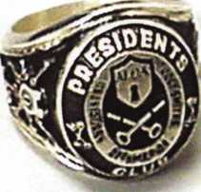

How can I join the President's Club?

You can earn a membership in this prestigious club by recruiting  
just 10 new members for ALOA.

*Any ALOA member may participate.

What do I get?

When you recruit 10 members, you receive a  
handsome blue blazer with a President's Club crest.  
For each additional five members you recruit, you  
receive a lapel pin with gold-filled numbers, indicating,  
your recruiting successes.

You also get the satisifaction of knowing that you are  
helping your association, helping your industry grow,  
and you are helping fellow locksmiths achieve success.

How do I get started?

Mail the form below to the ALOA office for a supply of  
applications (800) 532-ALOA or FAX (214) 827-1810.  
One President's Club credit is awarded for each new  
applicant. Credit is awarded only after the membership  
application is pproved. However, the credit will apply  
for the period in which the application is received.  
Failure to identify yourself as the sponsor on the applica-  
tion form at the time it is submitted to ALOA for process-  
ing will forfeit any credit.

S*c...

Yes! I want to join the ALOA President's Club.

Please rush me applications so I can start earning credit toward membership in the club!

Company

Address

City

Zip

Mail this form to ALOA • 3003 Live Oak • Dallas, Texas 75204-6186

The Customer Isn’t Always Right

By Eric Costley, CRL



Keynotes • May 2003

No matter what kind of retail business you may have  
experience with, you’ve probably heard it a million times:  
’’The customer is always right.” I beg to differ. Running a  
business means a great deal more than simply pleasing a  
customer. There are bills and employees to pay, overhead  
expenses, ordering parts and materials, vehicle mainte-  
nance, invoicing and receiving,  
and a myriad of other things to occupy your time.

So, when is the customer not right?

We have an unusual saying at our shop: FIRE THE  
CUSTOMER! Now, that may seem harsh to many of  
you, but if you had an employee that wasn’t pulling their  
weight at the shop, I’m sure that you wouldn’t hesitate  
to send them packing — and the same is true of a cus-  
tomer. There are some basic criteria that a customer  
must meet to make your business profitable, and after all,  
isn’t that what it’s all about? Let's take a look at some  
problem customers, so that you'll know who to fire.

First, (and foremost,) does the customer pay? Do they  
pay in a timely manner? If a customer isn't paying you  
what they owe you, and when they owe you, let's face it:  
He or she isn't a customer! If you've ever had a friend or  
family member who is always borrowing things and not  
returning them, you simply quit lending them things.  
Why should a customer have more clout than those who  
are close to you? Simply tell them that you refuse to do  
any more work for them unless the prior balance is paid,  
and that all further work is on a cash basis.

In addition, there is always a customer looking for a  
"deal." They call you once every two or three years to  
rekey a few locks, and since they give you "all their busi-  
ness," they expect that they should get some kind of hor-  
rendous discount, based on the fact that they are a faith-  
ful customer. I'm not insinuating that this customer  
should necessarily be disposed of, but let's be honest: If  
you do a fair job for a fair price, you deserve what you  
get. The good book says that "the meek shall inherit the  
earth." That's "meek," not "weak." Stick to your guns,  
and get the money that you deserve for the service you  
have performed.

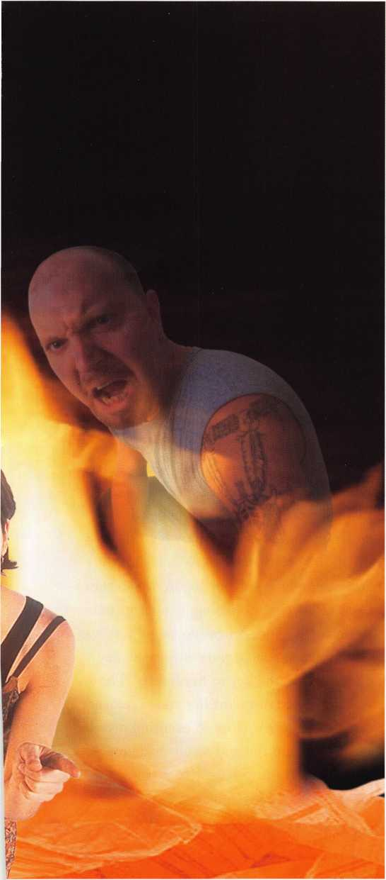

Keynotes • May 2003

**2**

Second, does the customer follow your recommenda­tions concerning their security needs? I?ve had cus­tomers that have been on the same screwed up mas- terkey system for 30 years or more. The masterkey is worn beyond recognition, with all extremely deep cuts. Whoever was previously doing the work had obviously been picking change keys at random, or just crosskeying new locks into the system. This is not only tedious and time consuming, but it represents a potential breach of security and liability waiting to backfire on you! I have begged and pleaded for the opportunity to completely overhaul the entire system, even if it meant just one or two locks at a time, with two simultaneous masterkey systems in place. If your customer doesn’t respect your knowledge and recom­mendations concerning their security, they don’t need a locksmith: They need to be left to their own demise. In such a case, draw up a nice letter explain­ing the problems inherent in the way things have been done in the past and express your regret at not being able to rectify the situation. Send it certified mail, and keep a copy on file to absolve yourself should any liability arise. And then?

Fire the customer!

Third, there are the wackos ... and you KNOW they're out there! Because we deal in a security indus­try, the paranoid come out of the woodwork to greet us! I had one customer track me down after I had left one shop and moved to another. She accused me of giving her house key someone, as if I had a copy lying

around, just waiting for someone to come in and ask for it. I advised her that if she were to continue in her allegations, that she would be speaking to my lawyer, and not to me. A few weeks later she was committed, permanently.

Not all is as it appears in this strange world, however. A long established commercial customer whom I also considered a friend came into the shop, very dis­traught. She was convinced that someone was going into her house while she was at work, not to steal, but to move things around, change the station on the radio, and other seemingly nebulous and harmless pranks. Based on our prior working relationship,

I gave her the benefit of the doubt and rekeyed her house. A short two weeks later, she returned and said someone was still getting in, terrorizing her. I promptly returned, and installed Abloy high security deadbolts on all the exterior doors. When she com­plained that someone was still getting in, I told the boss that I was afraid she was losing it. It turns out that she was perfectly sane. An employee of hers was borrowing her truck to run errands during the day, and on her keyring was the key to her house! The employee was hoping to discredit her and take over her job. I came dangerously close to excusing myself from this altogether, and the end result made me realize that it is important to trust the customer, sometimes even when their claims are suspect.

There are, of course, many valid reasons to dismiss customers. However, most of us are so entrenched in



Keynotes • May 2003

I had a disgruntled, (and drunk, I might add,) customer shove the business end of a loaded shotgun up my nose once.

the emotional need to please that we can’t see past the discomfort of the confrontation. What we often fail to see is that our ongoing discomfort and incon­venience is costing us our health and profit.

The first customer I ’’fired" was a large commercial customer. I was working as a sub-contractor at the time, and had to clear it first with the shop owner.

He said that it was up to me, but that he felt the same about the customer’s demands and disregard for our suggestions. I went home that night and spent a lot of time going over my records to see just how much of my pay I might be without in the very near future -- and I made a startling discovery! I would be absolute­ly amazed if any ONE customer of yours pays more than five percent of your gross income in any one year. Five percent! Think about what it would be like to liquidate that, and replace it with five more cus­tomers -- paying, satisfied customers who pay one per­cent each! Sometimes, less is more! Needless to say, another local locksmith picked up the account and came over to discuss it with me, and then had several not-so-pleasant names for me after that for "dump­ing" the account on him. (Did I warn him? OH, YES!) Have I ever regretted letting that customer go? Never.

Possibly the most common and obvious reason for stopping dead in your tracks on a job is the notorious "domestic situation." Family squabbles, divorce, or other potentially volatile situations tend to spark emotionally charged environments, rash decisions, poor judgment, and an unpleasant, (if not dangerous,) work environment. In such instances, it is best to sim­ply bow out graciously explaining that you will be glad to return and do the necessary work once the dust has settled, and the lawyers, police, or other authorities have made an official ruling. Walking away may irritate the customer initially but it protects your interests, your credibility and perhaps your life!

I had a disgruntled, (and drunk, I might add,) cus­tomer shove the business end of a loaded shotgun up my nose once. (I left in quite a hurry!) Two years later, she called and begged me to come out and rekey her house. I told her that the phone book was a good source for finding another competent locksmith, yet she persisted in begging and pleading and apologiz­ing... I did what you would do.... laugh, and hang up!

Another customer, fired.

The Customer ISN'T Always Right!

Most of us are so entrenched in the emotional need to please that we can't see past the discomfort of the confrontation.



Keynotes • May 2003



The New Frontiers of Key Extraction

By Don Dennis, CPL

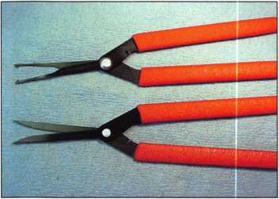

1: This photograph is of the new patent-pend­

ing extractor pliers being manufactured by Peterson Manufacturing. There is the Saw Blade (alligator-like jaws) and the Ice Tong Extractor Pliers.

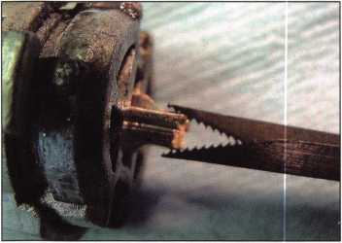

2: The Saw Blade Extractor Pliers makes a

very positive grip on a key blank fragment. The pulling power, while not measured, is enormous!

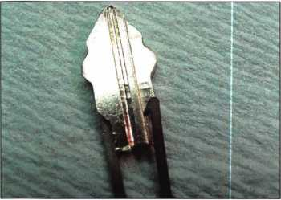

3: This is a close up shot of the Ice Tong

Extractor Pliers grabbing an H75 Ford blank. The pliers act as a ramp for the tumblers as the extraction takes place!

Only in the last io years has key extraction become an item of importance with tool manufactur­ers. Before this period, it was a time when new tools and ideas on extraction were rare with most of the attention restricted to minor comments. The justification for this probably lies in the mindset that patience was the only good tool for the endeavor. The lack of tools being produced only reaf­firmed manufacturing oversight in knowledge of a normal and daily locksmithing experience.

For all of these years our pick kits have boasted large awkward excus­es that the manufacturers called a key extractor. Never, in better than 30 years, have I ever been successful in using these “extrac­tors” to extract a key. I have never witnessed one used by another locksmith that was not drastically altered. Yet, they seem for some mystic reason to still exist! Maybe a picking kit is not really a bona fide kit without a big clumsy hunk of metal called an extractor.

Therefore, for all these years, the locksmith has altered the manu­factured extractors and broken picks into an artful form to do the job. It should also be mentioned that extractors have also been hand-made out of other odd item not used from a locksmith’s pick kit. The result of the time spent in

alterations provide a very personal touch to the locksmith’s arsenal. The only problem is that in today’s world (where labor is such a very high-cost commodity), it is only practical to make your own extrac­tors if there is no other way. It is hard to find a locksmith who has enough spare time to be laboring over extractor tool production until the very moment that the tool is needed.

Somewhere in the 1990s, HPC began to produce a much more refined set of instruments. It was such a drastic improvement, most locksmiths came on board quickly to eliminate the desperate need to produce the handmade extractor. The problem with the HPC solu­tion was only one. The extractor set was somewhat fragile. The extractor set came in a terrific variety of forms that were, for the most part, practical. The stems of the tool at the handle would bend and eventually break. The tips also had the tendency for breakage. Once, one of these tools went, then you went to the next tool in a kit of four. Generally, the straight single claw and the straight double claw extractors from these kits went first, leaving the angular claw tools in the collection untouched. These angular claws had limited uses. Soon, you were down to just two tools (the angular claws) remaining and you were back to

30

Keynotes • May 2003

making your own extractors until one more of the original four broke. At this point, you might be willing to break down and buy another set. HPC had certainly raised the bar on the concepts of extraction. This bar, however, has just been raised again!

Peterson Manufacturing has been producing extractors for only a short time. They started with the standard clumsy extractor, but found out quickly that the lock­smith was talking about the need for something more. Then they started to produce small-tipped extractors that were made out of the same metal as their picks. This made for a very stiff tool that filled more extraction needs. The extractors were tough, resisting breakage and holding sharp points on the pulling extraction claws. There were several varieties to chose from, but they were (and still are) hard to find anywhere except at the Peterson Manufacturing web site [www.peterson-international.com](http://www.peterson-international.com). These tools are truly terrific, but there is still a lack of what they can do in the extraction process. Mind you, there is not just one tool that will do it all. There never has been such an animal! HPC’s arsenal is a bit flawed in that they provide a thin, flimsy refined extractor that can be used most successfully in delicate situations. Peterson Manufacturing’s arsenal is too stiff for any delicate predica­ment, but long lasting and tough enough for most situations where strength is a mandate.

All of this leaves the locksmith only one step ahead. The major improvement is that there is no longer a requirement to make your own extractors unless you like or want to do so. You might just have a pot full of broken picks and would feel guilty if you just tossed them into the trash! Whatever your particular situation may be, we now come to the point where the game is becoming very excit­ing! Peterson has just come out with their new concept of extrac­tor pliers. That’s right! They are now making a configuration of three different pliers to make the extraction effort easier and boy, do they ever work! The tips of the first set are that of two standard single-clawed extractors placed adjacent to each other in a pliers format that is being called the “Ice Tong Extractor.” You can close down on a double-sided broken key blank and the key fragment will be able to move and tilt as you move it around in the keyway, allowing easy matching of the broaching of the key with the grooves in the key cylinder. If you recall the X7 blanks that would break off into the old Datsun igni­tion switches (becoming cocked in some of the most awkward posi­tions), you will be able to quickly note and understand the new capa­bility that the Ice Tong Extractor provides.

The second set of pliers called the “Saw Blade” comes in a left or right configuration to allow for “Right over Left” or “Left over Right” key blanks. These tools have jaws whose tips have alliga-

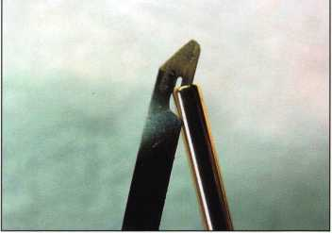

4: This is the Sidewinder Shim Extractor with

the furnished brass bending tube. The shim arrives in a flat configuration and the tube allows the user to place as aggressive a bend as they may desire on the Sidewinder’s tip.

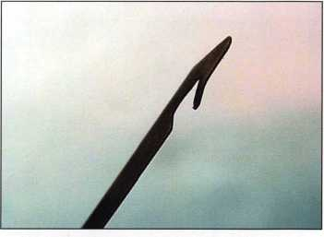

5: This is the bend that has been placed on the

Sidewinder’s tip. Also, know that each Sidewinder Shim Extractor has a solid han­dle made of the same plastic composite material as the Peterson Picks.

...we now come to the point where the game is becoming very exciting!

Keynotes • May 2003

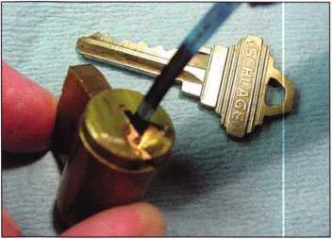

6: While this shot is a bit out of focus, it does

show the Sidewinder Shim Extractor insert­ed into an original Schlage “C” cylinder plug keyway. Either the tip will acquire a bit on a deep cut shoulder of the key blank or it will grab the key’s tip. Again, the tool will lift the tumblers allowing for an easy pull in the extraction process.

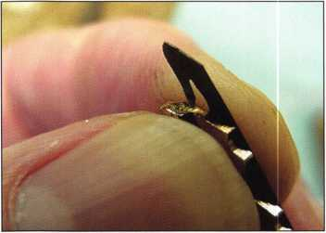

7: This photo shows the tip of the Sidewinder

Shim Extractor planting itself on the key’s tip. So long as the key blank fragment is not badly wedged, this tool will get the job done easily. It is a great addition to any extraction tool arsenal.

You will find that key extraction is never as sim­ple as what has been stated in some articles

tor-like teeth. These aggressive teeth, once set upon the key, are unrelenting. The photographs show the Saw Blade Extractors that are in a left-handed configura­tion. These work well on a blank such as the H75 Ford or Mazda X26. The right-handed configura­tion would work on a double-sided blank, which is the opposite broaching, like the Mazda X27. These different configurations allow a controlled grip without undue twisting, as the grip is made on the blank. Trying to use a left- handed configuration tool on an X27 would have the tendency to twist and spread the pliers’ jaw either breaking the pliers as they left the keyway or rendering a great deal of slack where the pliers are riveted. Either of these would result in a shortened life expectan­cy of the tool. Therefore, there is a need for two configurations in the “Saw Blade” extractor pliers. This need for two pliers configurations is not the case with the Ice Tong Extractors since they are meant to create a floating movement with the key fragment. The Ice Tong Extractors can also be slightly bent without creating tool breakage, allowing the sharp tips to touch rather than sliding past one anoth­er. This makes for a good stable grip on the key fragment and only applying too much pressure will split apart the jaws.

Another unique feature of all three of these tools is that the outer sur­faces of the pliers create a pair of ramps that automatically lift and the cylinder tumblers out of the way, making your key extraction a

simple “grab and pull” process. It is truly unbelievable what success can be enjoyed. The speed of the operation, in comparison to the past, is likewise astonishing.

The folks at Peterson have come up with one more new extraction concept. Besides their patent- pending pliers, they are beginning production of what they are calling their Sidewinder Shim Extractor. The name is a mouthful, but for delicate operations, it is a beautiful tool. This patent-pending idea slides a thin shim-like claw along side of a broken key blank. You may need to first insert a spiral extractor to hold the key where it is while this operation takes place. As the Sidewinder Shim is pushed alongside of the broken blank, the tip (which has been slightly flexed prior to the operation) will engage one of the remaining cuts in the blank or it will engage the very tip of the key fragment. Once engaged, it will be lifting the cylin­der tumblers allowing the operator to simply pull the fragment out of the keyway. The conditional requirements in using this tool are two-fold. First, the key fragment cannot be heavily wedged into the keyway. If it is heavily wedged into place, then you would no longer have a delicate extraction, but a situation requiring a much stiffer extraction tool. Secondly, there is enough room for insertion of the tool between the cylinder plug and the key blank. The Sidewinder Shim Extractor’s blade is a mere .004 inches thick and will work comfortably in an original Schlage “C” plug keyway (see photo). If

Keynotes • May 2003

these two conditions exist, then the sidewinder Shim Extractor will make it an easy job! Product avail­ability is expected in May 2003.

As with any extraction project, the locksmith must do several things upon arrival at the job site.

1. First, you want to make sure that there is a key fragment broken off in the keyway of the lock. Sometimes the cus­tomer can be mistaken and only think that the key broke off in the keyway.
2. Next you want to look at what is left of the customer’s key that is probably still on their key ring. Making certain that the broken key bow matches the keyway of the lock will also answer the likelihood that you are at the right lock for the extraction. You will also be able to note how much of a twist was exerted on the blank’s blade.
3. Finally, you want to carefully examine the keyway looking for how the key may be wedged or held in place.

Generally with these assessments, the next job is in the selection on tools to do the job. If the key is really embedded in the keyway with little room around it, the choice may be to drill a small hole into the fragment to allow the

usage of a finely tipped sturdy extractor. If the blank made a clean break and the blade is just barely past the cylinder plug’s sur­face, then a delicate extraction may work using a product like the new Sidewinder Shim Extractors. Of course, if the door is open and the lock can be removed (such as in a home or business), then that may be the easiest way with a good dollar return on your efforts.

You will find that key extraction is never as simple as what has been stated in some articles, since there are just too many possible varia­tions to deal with. This is probably the reason why, until now, that there has been a lack of tools on the market to deal with this kind of effort. You have all of the varia­tions of the different keyway pat­terns to be prepared for. There are shutters, ball bearings, and rollers that are present in just the auto­motive industry, not to mention padlocks. The list of possibilities is, in fact, limitless. We find that each outing is a learning process.

It doesn’t matter how long we have been in the trade, for no two extraction jobs will ever be dupli­cated. The more tools, the better for us all. The only other com­modities that the locksmith needs to provide in their efforts are a good sense of humor, great tenaci­ty, and plenty of patience.

The only other com­modities that the locksmith needs to provide in their efforts are a good sense of humor, great tenacity, and plenty of patience.

33

Keynotes • May 2003

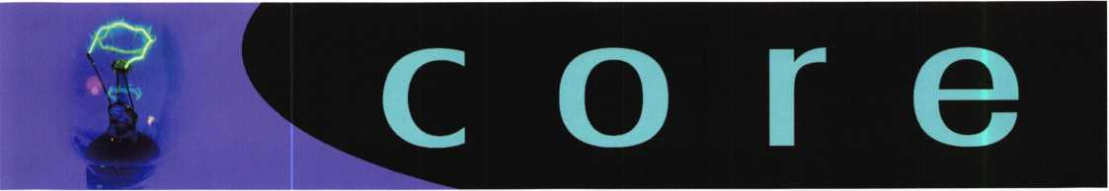

New CRLs:

MCMENIMON, BRADFORD SCANLON, GARY CLOUGH, SAMUEL J. LACOSTE, MARK D MCMENIMON, BARRY L PEREIRA, DENNIS J WHITE, W. SCOTT DUNLAP, JAMES L WILLIAMS, JOHN M HANSEN, TIM E BRANDON, JASON REYES, MICHAEL RIGGINS, COREY P. ANTHONY, ROBERT C SCRANTON, PAUL G MULLINGS, DAVID VITTY, KENNETH

New CMLs:

EDMUNDS, ANDREW A.

New CPLs:

GRAVER, BRANDON T

New CPSs:

DYER, RICHARD L WILSON, KEVIN

EASTON MA WESTWOOD, MA JACKSON, Ml PAWTUCKET, Rl ABINGTON, MA PROVIDENCE, Rl BUTTE, MT ALEXANDRIA, VA SAN DIEGO, CA LOGAN, UT URBANA, IL CHICAGO, IL PEORIA, IL EVANSTON, IL SCHILLER PARK, IL LONG BRANCH, NJ BAYVILLE, NJ

NEW LONDON, NH

NEW PROVIDENCE, A

COLORADO SPRINGS, CO LILBURN, GA

Let Us **Know!**

If you have an opinion to offer on ALOA, the state of the industry, or life in general, we want to know about it! Submissions to the "Mailbox" section of Keynotes are print­ed on a space-available basis. Write to: "Letters to the Editor"; ALOA; 3003 Live Oak Street; Dallas, TX, 75240; FAX 214/827-1810; e-mail: [editor@aloa.org](mailto:editor@aloa.org).

Need Help?

At ALOA, we want to make sure you are getting as much bang for your membership dues buck as we are able to give you. If you have had problems getting membership services, or have a question regarding member services, please contact Bill Gibson, executive director, at 800/532- 2562, or e-mail: [charlie@aloa.org](mailto:charlie@aloa.org).



**SAFE CORPORATION**

MANUFACTURES OF QUALITY DEPOSITORY SAFES AND CHESTS

DISTRIBUTING FROM WAREHOUSES IN

* LOS ANGLES**,** CA
* CHICAGO, IL
* GLASSBORO, NJ

A & B is now a stocking distributor

for Mutual Safes

featuring

AB-4-30-3S AB-9-2 WS 10-2

Chose from over 75 models in stock

We ship your order within

24 hours

See us

*of [www.a-bsafecorp.com](http://www.a-bsafecorp.com)*800-253-1267  
Fax 856-863-1208

CALL FOR YOUR  
CATALOG TODAY

**34**

Keynotes • May 2003

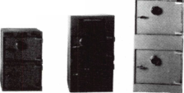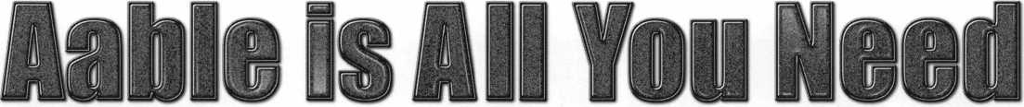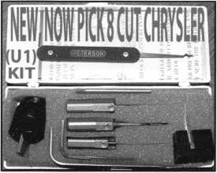

Universal Ford Flush-Mounted/Chrysler 8-Cut Ignition Removal Kit #U1 (patented)

Use this tool on all Ford flush mount ignitions, with or without side bar, large and small diameter face, all types of focus locks. With adapter, you can do virtually all Chrysler, Dodge, and Jeep 8-cut ignitions with no damage to lock. Similar kits sell for over $100.00 and only do Chrysler. Fit key and replace. In less than 5 minutes, you will have them out. Kit includes: 1 force tool (to remove face); 3 drill & arbors; 3 drill guides for all access holes; side B AR pressure tool; turn wrench; tumbler holding tool (to assemble and disassemble). No other tool needed with this kit. SFIOW SPECIAL: get free adapter for Chrysler, Dodge and Jeep with each kit. $155.00 +$6.00 S&H

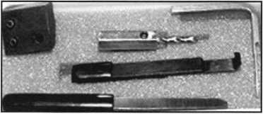

1998 Up G.M. In-Dash Ignition Removal Kit (patent 5454245)

Remove plastic ring and chrome cap in seconds. Make access hole to pick side bar. Turns cylinder to ACC position to remove lock in less than 5 minutes with no damage to lock. Your first job will pay for this kit. $70.00 + $6.00 S&H

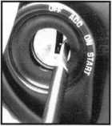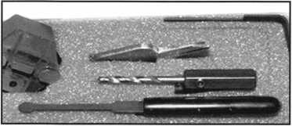

1996 Up Ford 8 Tumbler Ignition Removal Kit and Side Bar Breaker Tool

(patent 5701773)

Use force tool to turn ignition to “on” position in less than 60 seconds. To start car or for fast ignition lock removal or use kit to push side bar in, turn cylinder to “on” position for fast removal without any damage. Fit key, replace same lock. $90.00 + $6.00 S&H

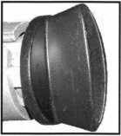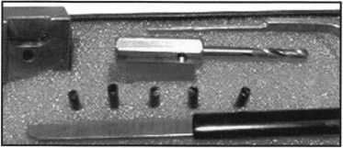

1994 Up G.M. 9 Tumbler Ignition Removal Kit (patent 5454245)

The locks have longer side bars than the older type and must be in the “on” position to remove. This kit will do that with no damage to the lock. Fit key and install same lock. Does all types, vats, mrd, top hat, module, etc. Your first job will more than pay for this kit. New with update to do module locks, blazers, suburbans, pick-ups, etc. $80.00 +$6.00 S&H

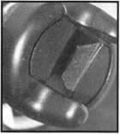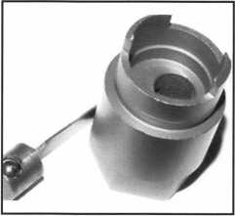

Ford “Quick-On” (patent 5454245)

Now turn all 10-cut ignition cylinders to the “on”  
position for fast removal-in less than 60 seconds.  
Sable, Taurus, all styles even those with airbags.  
No damage to housing.

$65.00 + $6.00 S&H

No-Nonsense Squeeze Lock Plug Remover

(patent 5165158)

Now you can remove all squeeze lock plugs in 15 seconds or less  
from all GM, Ford, Chrysler, AMC, and Jeep. No more fumbling,  
gadgets, cut fingers, broken tabs, or the need for 3 hands! It’s so  
easy you can do it in the dark while it’s still in the glove box.

$50.00 + $6.00 S&H

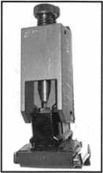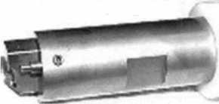

The G.M. Trunk & Door Persuader

The unique tool will open virtually all GM trunks and doors through the current year when tool fits into the cylinder core cavity in less than 50 seconds. No drilling, pulling, picking, special tools or electricity needed. When customer’s key does not open trunk because: Problem 1: spring retainer popped up into outer shell; Problem 2: One side of side bar sprung off. Side bar does not retract; Problem 3: key or cylinder worn. Side bar does not retract; Problem 4: Key jammed in lock at “turned” position, etc. With The Persuader you will open these locks in less than 50 seconds with no damage to lock. Just repair and replace. There is nothing to wear out. Yes, if needed, it will open with no key. Note: Because of The Persuader’s capabilities, it will be sold to locksmith only. $45.00 + $6.00 S&H

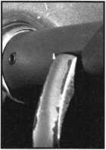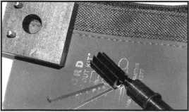

Ford “Disc-Out” Kit (patent 4682308)

This kit will remove those stubborn Ford pin ignitions from 1976 to present in less than 5 minutes. These locks incorpo­rate 2 locking devices and a hard steel disc across the shear line. They must be turned to “on” position to release both locking devices so as not to damage the housing. $60.00 + $6.00 S&H

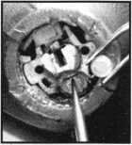

Frank Markisello guarantees all his products to do as stated.

[www.aablelocksmiths.com](http://www.aablelocksmiths.com) • 8619 97th Ave. • Ozone Park, NY 11416 • (718)848-8000

**Visit us at Booth #1321!**

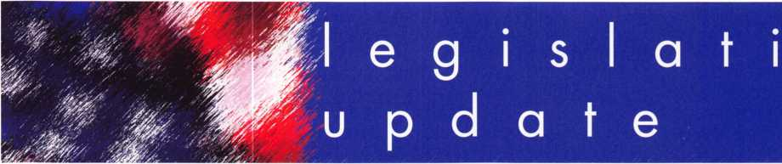

V

e

CONNECTICUT SB 14

SUMMARY: Requires the licensing of locksmiths.

STATUS: 03/25/2003 Failed Joint Favorable deadline

ILLINOIS SB487

SUMMARY: Creates the Private Detective, Private Alarm, Private Security and

Locksmith Act of 2004. Regulates private detectives and agencies, pri­vate alarm contractors and agencies, private security contractors and agencies, locksmiths and agencies, and employees of agencies by the Department of Professional Regulation. Amends the Criminal Identification Code, the Service Contract Act, the Vehicle Code,

STATUS: 04/09/2003 To House Committee on Executive

INDIANA HB1946

SUMMARY: Establishes a voluntary registration program for locksmiths who pass a

background check.

STATUS: 02/25/2003 Committee amendment adopted on

House floor.

LOUISIANA HB310

SUMMARY: Provides for the licensure of locksmiths and requires a license to install

and maintain access control devices and closed circuit television alarm systems.

STATUS: 03/31/2003 Introduced

MINNESOTA HB773

SUMMARY: Requires that employees of electronic security system companies,

undergo criminal history background checks.

STATUS: 03/26/2003 Referred to House Committee on Ways

and Means

NEVADA SB39

SUMMARY: Requires landlord to change entry locks of dwelling unit before deliver­ing possession of dwelling unit to new tenant.

STATUS: 02/03/2003 Introduced

02/03/2003 To Senate Committee on Judiciary

NEW YORK AB2646

SUMMARY: Establishes security requirements to be fulfilled by owners

of multiple dwelling units including deadbolt locks, window pins, ade­quate lighting, solid core doors, intercoms and optical viewers; provides requirements for each such security measure.

STATUS: 01/29/2003 Introduced and Referred to Assembly Committee

on Housing.

NEW YORK AB5024

SUMMARY: Provides that class A multiple dwellings having 8 or more apartments

erected or converted prior to 1968, must have automatic self-closing and self-locking doors at every entrance from the street, roof, passage­way, court yard, cellar or other entrance; excludes main entrance halls and lobbies if equipped with automatic self-locking doors.

STATUS: 02/24/2003 Introduced

02/24/2003 To Assembly Committee on Housing

NORTH CAROLINA SB655

SUMMARY: Makes clarifying changes to the definition of locksmith services under

the locksmith licensing act; amends the powers of the locksmith licens­ing board to allow the board to employ an attorney and allow the Department of Justice to conduct criminal history record checks upon the board's request; authorizes the board to require criminal history record checks of persons applying to practice locksmithing in this state.

STATUS: 04/01/2003 Introduced and sent to SENATE Committee on

Commerce.

NORTH DAKOTA HB1159

SUMMARY: Relates to the jurisdiction of the private investigative and

security board. Gives vague definition on what constitutes "security services"

STATUS: 01/07/2003 INTRODUCED and Referred to

Industry, Business and Labor Committee

02/03/2003 Failed to pass House.

SOUTH CAROLINA SB 186

SUMMARY: Provides certain instances in which dead bolt locks requiring a key for

operation on both sides may be used on exit doors.

STATUS: 01/14/2003 INTRODUCED and Referred to Committee on

Judiciary

TENNESSEE HB274 (also see SB656)

SUMMARY: Relates to the licensing of locksmiths.

STATUS: 03/25/2003 To House Committee on Commerce

TENNNSEE SB188

SUMMARY: Requires that all alarm system contractor employees who

sell, install or repair alarm systems, including closed circuit television systems, shall take and successfully complete the National Burglar and Fire Alarm Association Level 1 or equivalent training.

STATUS: 02/10/2003 To Senate Committee on Commerce,

Labor and Agriculture.

TEXAS HB2594

SUMMARY: Relates to the voluntary registration of locksmiths.

STATUS: 03/24/2003 To House Committee on Licensing and

Administrative Procedures. Copies of all these bills can be found at [www.aloa.org/news/legislation.cfm](http://www.aloa.org/news/legislation.cfm)

Coalition for Auto Repair Equality (CARE) and Automotive Alliance Meeting

ALOA participated in a meeting called for by Rep. Joe Barton (R-TX), sponsor of the "Motor Vehicle Owners' Right to Repair Act". Rep. Barton wanted the Alliance to know that he was willing to introduce his bill, and determined to have it pass this legislative session should aftermarket information be withheld. He also said, "and that includes the locksmiths" (he brought up the locksmiths three times in his remarks). CARE states the agreement that ASA and the Automotive Alliance drafted does not have an enforcement mechanism. The Alliance maintains that the way to make sure the information is out there is to use the National Automotive Service Task Force (NASTF) complaint form, which the automobile manufacturers respond to. The meeting was left with CARE to present to NASFT of all information that is still not available. ALOA submitted a list of automobile manufacturer models and years for cars that information to originate keys using scan tools is not available. This information was passed on to Rep. Barton's office. We are waiting on a reply from the Automotive Alliance.

Keynotes • May 2003

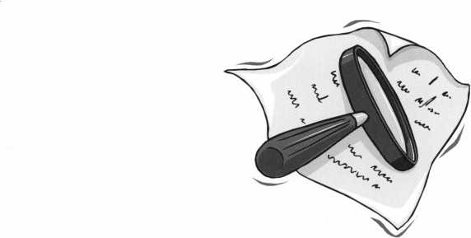

KEY CODE SERVICE

With proper ID and security clearance

we can get codes for most cars.

Fax us at 1-800-695-6810  
or call 1-800-741-4764  
for more information.

Hello, I'm Doug Jameson of Jameson Code Services. We would like to try and make your  
business just a little easier when you make a key. We can furnish a key code to you for  
almost all cars. There is no charge should the code we provide not work. We can have most  
codes back to you within 30 minutes. Some codes are even quicker such as Ford and  
Toyota. We furnish a pin number for Chryslers, also brake codes and immobolizer codes  
for Hondas and Acuras. We have been in the key code business since 1995 and learn a lit-  
tle more everyday. We are open Monday thru Friday 8:30 a.m. to 6:00 p.m. If you have a  
real emergency after these hours or on the weekend my pager number is 972-319-8782.  
There are a few brands I can get a code for after hours. All codes are $15.00. This includes  
a vat number if needed. The $15.00 also includes the pin number, brake code and  
immobolizer code. Corvettes are a special category as the vat numbers are not often avail-  
able. We would appreciate your input and welcome suggestions for improving our service.  
Give us a call at 214-630-0477 to set up your account or to have any questions answered.

Looking forward to servicing all locksmiths.

Fax US at 1-800-695-6810  
01 call 1-800-741-4764

ALOA Elections 2003

**FOR THE OFFICE OF PRESIDENT**



William L. Young,. CML

I began my career in locksmithing at the age of 13. After earning a degree  
in business administration from Mars Hill (NC) College, I entered the industry  
full time. I now am owner of A-l Security Center in Malvern, PA.

I have been actively involved in the Greater Philadelphia Locksmiths  
Association (GLPA) since 1985. I served that association as president, board  
chairman, vice-president, secretary, newsletter editor, and a director. I have  
been a member of ALOA since 1987 and a member of SAVTA since 1989. I  
am currently serving my third term as ALOA Northeast Director.

**FOR THE OFFICE OF SOUTHEAST REGION DIRECTOR**

VOTE FOR TWO (2) ONLY

Tom Gillingham, Jr., CML, CPS

I'm Tom Gillingham, and I am running for the position of Southeast Director of ALOA. A native of Nashville, Tennessee, I currently own and operate a successful one-man mobile locksmithing service. I have just recently married, and am looking forward to this yeans convention where my new wife will be taking beginning locksmith classes.

I fell in love with locksmithing ever since I purchased my first rack of keys and a key machine at age 11. By high school, I was attending seminars and receiving iThe National Locksmith? magazine. Then I worked my way through college as a locksmith. In 1990, I helped charter the Middle Tennessee Locksmith Association followed by assisting in the formation of our state association, the Tennessee Organization of Locksmiths. Both associa­tions are ALOA Affiliates and have worked closely with ALOA on issues involving membership and with legislation. I worked directly with Tim McMullen to help defeat a bill, which would have made it a felony in Tennessee to even possess flat steel keys or key machines. As a result of our work on the local level, I was awarded the LAN member of the year in

2000.

Vincent L. Formon, CML, CPS

I have been an active member of ALOA since 1987. I am the owner/opera- tor of Town & Country Locksmiths in Memphis, Tennessee. I am the former education chairman of the West Tennessee Chapter of ALOA and former treasure to the Tri-State Locksmith Association. I am presently the Southeast Director of ALOA seeking reelection and would appreciate your support.

|  |  |  |
| --- | --- | --- |
|  | location/ but in an organization such as ALOA, the three most important |  |
| II ^ Jgj | things are EDUCATION, EDUCATION, and EDUCATION! 1 plan to make |  |
|  | education my top priority and will work with the other Board members to |  |
|  | make sure that we maintain good quality classes at affordable prices. Please | j |
|  | participate in your association by placing your vote for Vincent Forman, | Ml |
| 1 -A. | CML, CPS, and Don Rule', CML for Southeast Regional Directors. Thank you. | ATI |

I have always been very active in both the local and national associations. After over a decade in local and state association offices, I am prepared for the job. My decision to run came after a large number of people approached me individually and told me I would be an asset to the board. I really like association work but, done right, it requires a lot of work, time, and energy. We have many locksmiths who are will not join ALOA because they feel no connection. I want our members in the Southeast to feel person­ally connected with ALOA by traveling to our various members and hearing their concerns. I want to give our Southeast members a name and a face to connect with ALOA when they need someone to discuss their concerns with. Most of all, I want to promote the need for national unity. As ALOA contin­ues to improve, new ideas are vital. I would like to bring some fresh approaches to our association based on my work on the local level.

Donald E. Rule, CML, CPS

I have been an ALOA member since 1986. I own and operate Boardtown Locksmith. I am a past president and life member of the Louisiana-Mississippi Locksmith Association. I am also a member of the Alabama Locksmith Association, the International Association of Investigative Locksmiths and the Safe and Vault Technicians Association.

In 1989 I was awarded a convention scholarship and in 1996 was appoint­ed as a member-at-large on the ALOA board. I have served as southeast region director since 1997.

As a member of the ALOA Legislative Action Network, I have appeared before legislative committees representing your concerns.

I believe ALOA should serve the locksmith by raising the level of profession- alism through education. On that note I now serve as the president of the ALOA Scholarship Foundation.

I would like to continue to represent your interests as your southeast region director. Your vote would be appreciated.

Ken Kupferman, CRL

I started my own business in the locksmith profession 18 years ago. I now have a large service center with over ten employees serving the Tampa, Florida area. My business is constantly changing with the developments of the locksmith, security profession including access control and CCTV, to meet all our customers' needs.

I have belonged to our local association (FWCLA) since 1995. I am currently the Treasurer of FWCLA and have been for the past four years.



I am on the SERLAC Board of Directors, which organizes our yearly educa-  
tion and trade show. I spent one year on the Exhibits Committee helping to  
arrange the exhibit show, two years on the Education Committee planning  
classes, two years on the Publicity Committee promoting the convention, and  
currently, I am the President of SERLAC.

When I get elected as an ALOA Director, my focus will be to help ALOA  
notify the general public of a locksmith's knowledge and skill in all aspects of  
security. I would also like to see ALOA become more pro-active rather than  
re-active when it comes to new legislation. Thank you for your vote.

Dear ALOA Members:

The Associated Locksmiths of America, Inc. (ALOA) Bylaws designate that the President of the Association and Directors from the Southeast, North Central and Southwest Regions shall be elect­ed in odd-numbered years. The Bylaws allow voting by proxy, a procedure that will allow all members to participate in the election of their respected officers. A proxy allows you to authorize someone to vote for you at a meeting.

As President, I have called a special membership meeting at 10:00am June 13, 2003 at ALOA Headquarters, 3003 Live Oak Street; Dallas, TX. The purpose of this meeting is to elect the President and Directors for the association.

The ballot is in the form of a proxy, prepared for you to give specific instruction to the holder of the proxy. This will ensure that your vote is counted exactly as you desire. You must provide your name, member number, and date and sign the form. Failure to properly complete the proxy may result in your ballot being invalid.

Although the election for President and Southwest Director are uncontested races, you should still vote. A proxy ballot is provided for this purpose. ALOA members in the North Central and Southeast Regions shall also be mailed a proxy ballot.

Please vote for President and your representative Director. Write-in candidates are not allowed and there will be no one "running from the floor" at this special meeting of the membership.

The Secretary, Associate, Northeast, South Central, Northwest, Asian and European Region Directors are elected in even-numbered years, and therefore do not appear on this ballot.

Please mail or fax the proxy as soon as possible. In order for your vote to count, the holder of your proxy, as designated, must be present at the meeting and have the properly completed proxy with him/her. This means that your ballot must be received no later than Wednesday,

June 11, 2003. You do not have to designate Paul Kanitra and Mary May as your proxies. You may give your proxy to anyone else, but they must attend the special membership meeting on June 13, 2003 with your signed and dated proxy in hand.

Please participate in the future of your association!

Sincerely,

ASSOCIATE LOCKSMITHS OF AMERICA, INC.

Randy L. Simpson, CML President

**FOR THE OFFICE OF SOUTHWEST REGION DIRECTOR**

VOTE FOR TWO (2) ONLY

(Eligible to vote: Active, Apprentice, Retired, Life and Associate members who's business address is in Arizona, California, Colorado, Hawaii, Nevada, New Mexico, Utah):

Gordon R. Racine, CML

In October 1980, I started my career in the locksmith profession by opening a Lock & Key service out of my home. I worked part time for seven years before my locksmith business became so successful I either had to quite my full time job or my locksmith business. I made the right choice! In 1984, I joined ALOA, member number 11643, and have attended many conven­tions and taken advantage of the many classes offered. Over the years I have turned a dream into a reality and now have a locksmith & security company with 6 employees that services a trade area of over 50 miles with a population of about 35,000 people. I am currently in my second year as

|  |  |  |
| --- | --- | --- |
| f or, - 1 | ALOA, 1 am a member and past president of the Central & Southern  Colorado Locksmith Association, member of the Rocky Mountain Locksmith  Association. 1 believe in community participation and am a member and past president of the La Junta Kiwanis Club, as well as a member of La Junta | 1 7 J |
|  | Chamber of Commerce. Volunteering is my way of giving back to the com­ |  |
|  | munity and the locksmith industry. We have a proud industry and history. |  |



I Together it can only get better.

Julie McCluney, CRL

I have been serving on the ALOA board for the past 2 years. It has been a  
rewarding experience. I have voted on many important issues that industry  
and our association. I have tried to make a difference! It is not the "good  
old" days, ALOA has moved on to the use of Governance Policies which  
empower the ALOA Executive Director and staff to run ALOA in an efficient  
and ethical manor. These policies are tedious to write and involve a lot of  
forethought. Understanding the methodology behind this type of policy writ-  
ing had taken a lot of Board time. New Board members are now required to  
go through refresher courses throughout their term. Experienced Board mem-  
bers are making a difference in the association as they have brought the  
Governance Policy to where it is today. It is important that Board members  
understand the importance of writing clear and precise policies to get the job  
done - I understand that concept and would strive to introduce and complete  
new policies that would positively effect our association. What I would like to  
bring to the Board are new ideas that take technology and the 21 st Century  
to ALOA. My visions include bringing the PRP to your city 5 days a week,

52 weeks a year, allowing more members to achieve certified level designa-  
tion. Education focus via the ALOA website, PRP test questions updates,  
increased visibility and recognition of ALOA members though technology  
and store certification. I would like to open a discussion to examine ALOA's  
Code of Ethics and update such as well as promote legislative awareness  
among our members. If reelected I would strive to achieve the above goals  
and work with the rest of the Board to improve ALOA for its membership. I  
am currently President of Hill's Bros. Lock & Safe, Inc. and Keedex, Inc. in  
Garden Grove, California. I graduated from Loyola Marymount University  
with a degree in Business and am also an Asssociate Board Member-Boys  
and Girls Club of Garden Grove, as well as a member of the Garden Grove  
Chamber of Commerce, International Facilities Managers Association and  
the ALOA Legislative Action Network. My interests included Topical Stamp  
Collecting "Keys" and Sign Language.

**FOR THE OFFICE OF**

**NORTH CENTRAL REGION DIRECTOR**

VOTE FOR TWO (2) ONLY

(Eligible to vote: Active, Apprentice, Retired, Life and Associate members who's business address is in Illinois, Indiana, Iowa, Michigan, Minnesota, Nebraska, North Dakota, South Dakota, Wisconsin):

Mark E. Blum, CML, CPS

I have worked in Locksmithing industry for 42 years, and been a member of  
ALOA for 28 years (joined in March of 1973). I am also a member of four  
state locksmith associations, and have been a member of ASIS for 19 years  
(since 1984). I currently serve as the North Central Director on the ALOA  
Board of Directors where I am a member of the ALOA Curriculum  
Development Committee. I am a Certified Instructor for ALOA, and during  
the last 15 years taught classes in seven subjects to participants in 14 States.

I am proud to have taught attendees at local and regional hospital associa-  
tions, law enforcement agencies, ACE classes, ALOA conventions, state and  
local locksmith associations and real estate development groups. For my  
efforts, I received the first ALOA A.C.E. award in 1990 for my efforts in fur-  
thering educational opportunities for locksmiths. I have produced public serv-  
ice videotapes promoting informed decision-making when purchasing locks  
and safes for local cable television channels. I was the first CML in the State  
of Michigan.

John W. Soderland, CML, CMST

I am John Soderland, and I am running for North Central Director. I started  
to learn locksmithing while in the U.S. Navy in 1970. My first job as a civil-  
ian was for a locksmith shop in Milwaukee, Wisconsin, where I worked for  
16 years. In 1986, I started my own shop in the area of Milwaukee, which  
has grown to employ five full-time locksmiths. We primarily service commer-  
cial and the industries clients. I started attending ALOA conventions early in  
my career. I felt that then, as now, the classes are enjoyable and informative  
the opportunities to meet other locksmiths across the country and world give  
me a fresh prospective on my own business. I owe a large part of my suc-  
cess to the help I received from other members in this trade throughout the  
years. I am motivated to help others through the tough times I already have  
been through. I hope through my directorship to repay the kindness shown  
to me. I offer my experience to help keep the association strong. I feel the  
future of ALOA lies in the sharing of knowledge and improvement of skills.  
My representation will reflect the desire of our members to advance their  
trade in the eyes of the public, retain their rightful place in the workforce  
and uphold the integrity as the cornerstone of this profession.

Guy M. Spinello, RL

I have been involved in the locksmith business since age 13; a full-fledged  
locksmith since 1969. I am an active member and participant in the  
Northern Illinois Locksmiths Association and the Allied Locksmiths of Illinois.  
My membership in the ALOA began in 1971 (Membership #3306). I was  
extremely active and supportive in developing modern day standards for  
locksmithing through my affiliation with ALOA and working with other lock-  
smiths with similar goals, both at the local and regional level. My back-  
ground includes all facets of security sales, service and installation, including  
consultation, planning and installation of complex systems.

I would bring to the ALOA a background of nearly fifty years of experience,  
honed by technological hands-on involvement from basic business practices  
through decades of improvement in management and technical savvy. I  
would work to encourage unity throughout the locksmithing field . I would  
support ongoing training programs for all practicing lockmsiths. I would  
work to have locksmiths revered as professionals.



The undersigned, being the Associated Locsmiths of America, Inc. (ALOA) member, hereby appoints Paul Kanitra and Mary May the proxies and true and lawful  
attorneys of the undersigned to attend the Meeting of the Membership of ALOA to be held at 3003 Live Oak Street, Dallas, Texas 75204 on June 13, 2003 at  
10:00 a.m. or any adjournment therof, and to vote on behalf of said ALOA Member as designated below:

FOR THE OFFICE OF PRESIDENT

VOTE FOR ONE (1) ONLY

(Eligible to vote: Active, Apprentice,

Retired, Life and Associate members):

□ William L. Young, CML

This proxy must be signed and dated with  
member number to be considered valid. It  
must be received no later than June 11,

2003 and be mailed/faxed only to:

**Associated Locksmiths of America  
Attn: Paul Kanitra  
3003 Live Oak Street • Dallas,**

**Texas 75204  
Fax: 214-827-1810**

FOR THE OFFICE OF SOUTHEAST REGION DIRECTOR

VOTE FOR TWO (2) ONLY

(Eligible to vote: Active, Apprentice, Retired, Life and Associate members who's business address is in Alabama, Florida, Georgia, Mississippi, North Carolina, Puerto Rico, South Carolina, Tennessee):

* Vincent L. Formon, CML, CPS
* Donald E. Rule, CML, CPS
* Tom Gillingham, Jr., CML, CPS
* Ken Kupferman, CRL

FOR THE OFFICE OF SOUTHWEST REGION DIRECTOR

VOTE FOR TWO (2) ONLY

(Eligible to vote: Active, Apprentice, Retired, Life and Associate members who's business address is in Arizona, California, Colorado, Hawaii, Nevada, New Mexico, Utah):

* Gordon R. Racine, CML
* Julie McCluney, CRL

FOR THE OFFICE OF NORTH CENTRAL REGION DIRECTOR

VOTE FOR TWO (2) ONLY

(Eligible to vote: Active, Apprentice, Retired, Life and Associate members who's business address is in Illinois, Indiana, Iowa, Michigan, Minnesota, Nebraska, North Dakota, South Dakota, Wisconsin):

* Mark E. Blum, CML, CPS
* John W. Soderland, CML, CMST
* Guy M. Spinello, RL

Print/Type name of ALOA Member

Member Number

Member Signature



EMPLOYMENT

LOCKSMITH/BUSINESS PARTNER

Growing locksmith company in Edmonton, Alberta, Canada (and surrounding area) requires a locksmith/business partner. We are looking for a hard working, dedicated individual with a desire to further his/her career. Please send or fax your resume to: Robert Richard • Knight Lock and Safe Box 21043 • Leduc, Alberta T9E 6R4 • Fax (780) 980-8283 e-mail: [knightlocksnsafe@aol.com](mailto:knightlocksnsafe@aol.com)

LOCKSMITH WANTED

NW Pennsylvania. Rapidly growing company. New retail store. Looking for locksmith for outside service. Mostly commer­cial work. Safe servicing and access control experience a plus. If you enjoy outdoor sports of all kinds, including hunting and fishing, this is the place to live. Contact: Uhlig Lock and Safe

16325 Conneaut Lake Rd.

Meadville, PA 16335

814/724-2255 • (814) 724-1687 (fax)

[lockdoctor@alltell.net](mailto:lockdoctor@alltell.net)

STOP LOOKING!!!!! EXPERIENCED TECHNICIANS WANTED

Lock into your future now! If you are experienced, intelligent, and desire a secure future, come join our team. We are a full service commercial/residential security service (locks,keys,safes,cctv,access control, door related hardware). We offer: sign on bonus, top wages, company vehicle, 401k, paid vacation, paid holidays, new uniforms, cross training, and job satisfaction. We are looking for the best tech's, who are ready to be treated and compensated as professionals. Bass Security Services, Inc. • Ph#216-755-1200 ex.# 128 • Fax#216-755-1220 • E-MAIL/ [rmesnick@bass-security.com](mailto:rmesnick@bass-security.com)

LOCKSMITH WANTED

Busy shop in Woburn, MA, has immediate opening for a self- motivated, ambitious locksmiths. We have a large customer database for automotive, AAA, commercial and residential accounts. Applicants with own van and tools are guaranteed 50 percent commission. We supply more expensive tools, such as TCL, NGS, other transponder programming tools, etc. No waiting to get paid, no having to be available 24 hours a day to make a good week's pay, and no worrying about the enor­mous bills associated with being self-employed. (Yellow pages, direct mail, answering services, pagers, office supplies, office payroll, rent, heat, electric, and other bills that can add up to more than your gross!) If you feel you're a great locksmith and want to be rewarded for your experience, this is for you. If you currently own your own business now and don't want all

the headaches of being in charge of advertising, human resources, customer relations, payroll, accounts, receivable, accounts payable, dispatch, etc., let us know if you want to be a partner. Too many great locksmiths go out of business for try­ing to do it all. If you feel this is an opportunity you would like to know more about, send resume to: Locks & Keys, Inc. •

P.O. Box 222 • Woburn, MA 01801 Or call John at (781) 933-9999

ACCOUNT EXECUTIVE WANTED

We are seeking an energetic, experienced sales professional to join our rapidly growing team. Candidate must possess a strong background in commercial hardware as well as elec­tronic access control, (cctv and alarm experience is a plus!). Minimum 5 years sales experience required. We offer: Top wages, commission, expense account, 401k, paid vacations and holiday, hospitalization. E-MAIL resume to: [rmesnick@bass-security.com](mailto:rmesnick@bass-security.com) or phone-216-755-1200 ext# 128.

AUTOMOTIVE LOCKSMITH WANTED

Relocate to South Florida and throw away your deadbolts and three keys for a dollar. We run over 300 calls per week. You must own a truck with tools and code equipment to cut all for­eign and domestic keys. You can earn $800 to $1500 per week. South Florida Lock and Safe. 800/928-2926. Please if no truck or tools, no calls.

LOCKSMITH WANTED FOR S. ORANGE COUNTY.

Experienced in all areas including access control and safes. Permanent position with excellent compensation and benefits including bonus, overtime, health plan, retirement plan, sick leave, paid vacation and holidays. Van and tools provided. Call 949.492.5700 or fax resume to 949.492.0246. TONY's LOCKSMITH AND SAFE SERVICE • 217 South de la Estrella • San Clemente, CA 92672

HELP WANTED

Argens, Inc., a 123-year-old security company located in Seattle, is seeking applications for two positions. Jorneyman locksmith with expert hardware installation skills. Must be able to perform all facets of hardware installation and the ability to improvise when required. Also Journeyman Dispatcher must have experience in all facetss of locksmithing and installation. Excellent pay, benefits and IRA. Fax resume to 206-622-5056 attn. Steve T.

HELP WANTED

Emory is one of the five largest private employers in the Atlanta metro area and the largest employer in Dekalb County. The University is admired worldwide for academic, patient care, research and technological excellence. As an Emory employee, you are part of a community which values diversity, education, training, and personal development. Creativity and innovative ideas are nourished and rewarded. We invite you to share in a unique culture of education, research and health care.

We currently have a great opportunity for a Supervisor, Security Systems in our Security Shop. They will Provide lock­smith, alarms, control systems and security system services including installing, repairing, inspecting, and recombination mechanical, electro-mechanical, electronic locking and moni­toring devices and door hardware. Performs diagnostic tests on digital, key pad and card-locking, and other electronic locking systems for the University.

MINIMUM QUALIFICATIONS: High school diploma or equivalent. Five years combination locksmith and electronics/security systems experience, including two years supervisor experience. Thorough journeyman level knowledge and skills in mechanical, electro-mechanical, electronic locking and monitoring devices and door hardware. Journeyman level skill in maintenance and repair procedures including pre­ventive maintenance, breakdown repair and troubleshooting, construction, installation and fabrication techniques typical in trade; perform mathematical computations of trade.

Knowledge of ADA specifications and proper use and mainte­nance of hand and power tools, test equipment and electron­ics equipment related to job functions. Valid Georgia driver's license and insurable driving record. Some positions within this classification may require the ability to lift 50 pounds and to bend, stoop and twist.

Departmental Information/Preferred Qualifications: Ideal candidate will have a high degree of organizational, commu­nication, customer service, and good leadership skills.

We offer competitive salaries and world-class benefits including major medical/dental/vision/life insurance, disabili­ty insurance, paid holidays/vacation, tuition assistance, a gen­erous employer matching 403(b) retirement plan and courtesy scholarships for family members and same-sex domestic part­ners. For more information about our benefits, please visit our website at: <http://emory.hr.emory.edu/benefits.nsf>

A career with Emory University affords a level of prestige and stability not found in many Atlanta Employers of Choice. We invite you to become a part of the Origins of Excellence!

Please submit your resume via (online from) the Emory Careers Website at emory.hr.emory.edu/careers.nsf or by mail at Emory University, 1762 Clifton Road, Atlanta, GA, 30322. Phone: 404.727.761 1 Fax: 404.727.1922 Please reference Job posting 136542 when applying.

Emory University is an AA/EOE Employer

Classified Advertising Policy

Classified advertising space is provided free of charge to ALOA members, and fora fee of $.60 per word, $15 minimum for non-members. Classified ads may be used to advertise used  
merchandise and overstocked items for sale, "wanted to buy" items, business opportunities, employment opportunities/positions wanted and the like. Members or non-members wishing to  
advertise services or new merchandise for sale may purchase a "Commercial Classified Ad," for a fee of $1.30 per word, with a minimum of $40. Each ad will run for two issues. For  
blind boxes there is a $5 charge to members and non-members. All ads must be submitted in writing to the ALOA office by the fifteenth of the month, two months prior to issue date. Send  
to Keynotes Classifieds, 3003 Live Oak St., Dallas TX 75204-6186. ALOA reserves the right to refuse any classified advertisement that it deems inappropriate according to the stated pur-  
pose of the classified advertising section.

Keynotes • May 2003

BUSINESS FOR SALE

BUSINESS FOR SALE

Locksmith glass and screen business located in fast growing NW Arizona between Kingman, AZ, and Laughlin, NV. Well- equipped 1995 Dodge van and leased shop on busy high­way. All equipment and inventory included. $48,900 takes all. Health demands retirement. Call (928) 565-2294 or e-mail at [lmburks@ctaz.com](mailto:lmburks@ctaz.com).

COMMERCIAL LOCK BUSINESS FOR SALE

Commercial locksmith company specializing in high tech, high security sales, service and installations is for sale. Business was established in 1978 and is located in the Inland Empire of Southern California. ASSA dealer with six keyways and most accounts are on the ASSA system. Residential and auto­motive are currently referred to others, so there is lots of room for expansion. Excellent high security addition to an existing lock business or instant income for a rookie or retiree. Retiring and moving to the northwest, so business is priced to sell fast! Call 909-29-8480 for details.

BUSINESS FOR SALE

Owner Retiring. Well-established business in central Ohio, est. 1965. Sale includes equipment, inventory, 2000 Dodge Ram 2500 van. Commercial and residential accounts. We are a Medeco Patriot dealer for the county and surrounding area. Call 419/562-4896, or write to: Wink's Lock and Safe •

1 13 W. Warren St. • Bucyrus, OH 44820

FOR SALE

Well-established lock shop, fully-equipped shop van. Hub city, serving all of northeastern Nevada. Same location for 20 years. Large commercial clientele. Great outdoor recreational area, hunting, fishing, etc. Elko Lock and Safe.

Call 775/738-3938, fax 775/738-2370.

FOR SALE

Overstock, New Von Duprin 33NL-OP, 33EO, E99K,

3347EO, 9947EO, CD3347TL, EPT-10, Von Duprin electric strike 6211, 6233. Rixson mag hold 980,997 Locknetics 505. Please call for price. Kevin at 915-553-3145, or e-mail reddog2501 @excite.com.

COMMERCIAL LOCK BUSINESS FOR SALE

Commercial locksmith company specializing in high tech, high security sales, service and installations is for sale. Business was established in 1978 and is located in the Inland Empire of Southern California. ASSA dealer with six keyways and most accounts are on the ASSA system. Residential and auto­motive are currently referred to others, so there is lots of room for expansion. Excellent high security addition to an existing lock business or instant income for a rookie or retiree. Retiring and moving to the northwest, so business is priced to sell fast! Call 909-29-8480 for details.

LOCKSMITH MOBILE SERVICE FOR SALE

Established Mobile Locksmith Service in the Bay Area. Specializing in Automotive and Residential with some light commercial work. Territory covered is Fremont, Hayward,

Union City and Castro Valley in California. Three trucks are currently be used in the area. Fully equipped with tools and key machines. Professionally labeled vehicles that are well kept up. This territory averages in gross sales per year is around a half a million dollars.

We are looking for highly qualified individual that is self motivated to take over operations. Willing to sell for a rock bottom price to the right individual. Desperate to sell immedi­ately. Please call for details.

Robert Bradley • 510-760-4372

WANTED TO BUY/SELL

BACK ISSUES!

FOR SALE: Assorted Issues of locksmithing publications including Keynotes, Locksmith Ledger, The National Locksmith, Reeds, etc. dating from the early 1980s. Contact Richard at 281-931-7525 to make offer.

DISTRIBUTOR WANTED

Veteran manufacturer (since 1935) of security products for vehicle protection against theft is looking for agents and dis­tributors of our products. We manufacture mechanical parking posts, steel barriers and "Denver boots" (wheel clamping against theft devices). Please contact Kantero Israel:

Fax 972-3-6837228, or e-mail: i.k.a.@hotmail.co.il

WHOLESALE SAFE DEPOSIT LOCKS

Allied, Diebold, Herrin, Hall & Mavin, llco, Lefabure, Mosler, Precission, S&G, Security Corp., Yale. Locks from early 1900s to current. Call or email for lock type and pricing sheet. Quantity discounts. Call WBI at (954)484-2404 or email: [sales@wbi.us](mailto:sales@wbi.us)

NEED CASH?

Have you recently sold your locksmith business, or are you selling it now? Are you carrying the financing? We can give you a lump sum of cash now for all or a portion of your remaining payments. RED OAK FUNDING. 630/483-0335, [www.redoakfunding.com](http://www.redoakfunding.com)

LIQUIDATION SALE!

By appointment only. After 55 years of doing business, A- Armitage Locksmiths is closing its doors! Merchandise, lock supplies, key machines and much more! Most items are being offered 30 percent below wholesale prices! All sales final. Please bring a copy of your Illinois tax exempt registration to purchase the goods.

Weekday appointments call (773) 339-4535 Weekend appointments call (815) 238-0800

FOR SALE

Framon Tool Key Machine, 110-volt and 12 volt motor, good condition, hardly used. $1300 plus shipping. Call Curt at 808/696-9421 for further details.

ITEMS FOR SALE

Locksmith items left over from closed business. Will sell at rea­sonable price. Must sell, have no room to store. Most keys are of older years, eg H50, H51, XI21, X39 and so on. Several thousand keyblanks, ranging from A to Z. Several boxes of automotive locks of all sorts. Several Weiser Crown and other knobs and deadbolts. Several pinning kits of all kinds. Three Gardall safes, no combos have been changed, two 1812 rotary hoppers and one double door rotary hopper. Everything at real good prices. Call Ron at 817/346-1286, or write to 6520 Andora Ave., Ft. Worth, TX, 76133. For a list of key- blanks and other material. Or e-mail: [rgdretusaf20@aol.com](mailto:rgdretusaf20@aol.com).

**TURD tO**

WHOLESALE SERVICE

* In-Stock... **SAFES**
* FREE Freight Program
* Fax: 800-391-4553

800**-**848-9790

FreKing Gardall HAYMAN MEIUNK **\flCTOR**

Keynotes • May 2003



Distributor

ADI Inc

Phone: 631-692-1000 Fax: 631-692-3011

Accredited Lock Supply Co

Phone: 201-865-5015 Fax: 201-865-0030 [www.acclock.com](http://www.acclock.com)

Ace Lock & Security Supply

Phone: 908-688-7666 Fax: 908-688-2442 [www.acelock.com](http://www.acelock.com)

Action Hardware Inc

Phone: 800-662-6695 Fax: 800-930-2329

Andrews Wholesale Lock Supply

Phone: 717-272-7422 Fax: 717-274-8659 [www.andrewslock.com](http://www.andrewslock.com)

Boyle & Chase Inc

Phone: 800-325-2530 Fax: 800-205-3500 [www.boyleandchase.com](http://www.boyleandchase.com)

Chinrose International

Phone: 503-357-7553 Fax: 503-357-5522 [www.chinrose.com](http://www.chinrose.com)

Clark Security Products

Phone: 800-854-2088 Fax: 619-974-5284 [www.clarksecurity.com](http://www.clarksecurity.com)

Cook's Building Specialties

Phone: 505-883-5701 Fax: 505-883-5704

Dire's Lock & Key Company

Phone: 303-294-0176 Fax: 303-294-0198

Direct Security Supply; Inc.

Phone: 800-252-5757 Fax: 800-452-8600

Doyle Security Products

Phone: 800-333-6953 Fax: 612-521-0166 [www.doylesecurity.com](http://www.doylesecurity.com)

Dugmore and Duncan, Inc.

Phone: 888-384-6673 Fax: 888-329-3846

E. L. Reinhardt Co., Inc.

Phone: 800-328-1311 Fax: 651-481-0166 [www.elreinhardt.com](http://www.elreinhardt.com)

Ewert Wholesale Hardware

Phone: 800-451-0200 Fax: 708-597-0881

Fairway Supply, Inc.

Phone: 214-350-0021 Fax: 214-352-4299 [www.fairwaysupply.com](http://www.fairwaysupply.com)

Foley-Belsaw Company

Phone: 800-821-3452 Fax: 816-483-5010 [www.foley-belsaw.com](http://www.foley-belsaw.com)

Fried Brothers Inc.

Phone: 800-523-2924 Fax: 215-592-1255 [www.fbisecurity.com](http://www.fbisecurity.com)

H L Flake Co

Phone: 800-231-4105 Fax: 713-926-3399 [www.hlflake.com](http://www.hlflake.com)

H.S. & S. Wholesale Distrib.

Phone: 313-342-6777 Fax: 313-342-7580

Hans Johnsen Company

Phone: 214-879-1550 Fax: 214-879-1530 [www.hjc.com](http://www.hjc.com)

Hardware Agencies, Ltd.

Phone: 416-462-1921 [www.hardwareagencies.com](http://www.hardwareagencies.com)

IDN Incorporated

Phone: 817-421-5470 Fax: 817-421-5468 [www.idn-inc.com](http://www.idn-inc.com)

Intermountain Lock & Supply

Phone: 800-453-5386 Fax: 801-485-7205

[www.intermountainlock.com](http://www.intermountainlock.com)

Jo Van Distributors

Phone: 416-752-2238 Fax: 416-752-7282 [www.jovanlock.com](http://www.jovanlock.com)

KeylessRide

Phone: 877-619-3136 Fax: 409-216-5058 [www.keylessride.com](http://www.keylessride.com)

Lockmasters, Inc.

Phone: 859-885-6041 Fax: 859-885-7093 [www.lockmasters.com](http://www.lockmasters.com)

Locks Company

Phone: 800-288-0801 Fax: 305-949-3619

Locksmith Ledger International

Phone: 770-886-0800 Fax: 770-889-7703 [www.lledger.com](http://www.lledger.com)

M. Zion Company

Phone: 212-349-8677 Fax: 212-964-0495 [www.mzion.com](http://www.mzion.com)

McDonald Dash Locksmith Supp

Phone: 800-238-7541 Fax: 901-366-0005 [www.mcdonalddash.com](http://www.mcdonalddash.com)

McManus Locksmith Supply, In

Phone: 704-333-9112 Fax: 704-332-8664

Monaco Lock Co.

Phone: 800-526-6094 Fax: 800-845-5625 [www.monacolock.com](http://www.monacolock.com)

Omaha Wholesale Hardware

Phone: 800-238-4566 Fax: 402-444-1664 [www.omahawh.com](http://www.omahawh.com)

Phoenix Safe International LLC

Phone: 765-483-0954 Fax: 765-483-0962 [www.phoenixsafeusa.com](http://www.phoenixsafeusa.com)

Professional Business Products

Phone: 248-360-3979

Fax: 248-360-3982

[www.professionalbusinessproducts](http://www.professionalbusinessproducts)

RA-Lock Company

Phone: 972-775-6301

Fax: 972-775-6316

[www.ralock.com](http://www.ralock.com)

SecureRite.Com

Phone: 800-241-3930

Fax: 858-974-5269

[www.SecureRite.Corn](http://www.SecureRite.Corn)

Security House

Phone: 905-669-5300 Fax: 905-660-6313 [www.securityhouselock.com](http://www.securityhouselock.com)

Security Lock Distributors

Phone: 800-847-5625 Fax: 800-878-6400 [www.securadealer.com](http://www.securadealer.com)

Sentry Security Fasteners

Phone: 309-693-2800 Fax: 800-693-2872

Somerset Security Products

Phone: 800-881-5206 Fax: 800-206-9949

Southern Lock and Supply Co.

Phone: 727-541-5536 Fax: 727-544-8278 [www.southernlock.com](http://www.southernlock.com)

Stone & Berg Wholesale

Phone: 800-225-7405 Fax: 800-535-5625

The Locksmith Store Inc.

Phone: 847-364-5111 Fax: 847-364-5125 [www.locksmithstore.com](http://www.locksmithstore.com)

Timemaster Inc

Phone: 859-259-1878 Fax: 859-255-0298 [www.time-master.com](http://www.time-master.com)

Top Notch Distributors, Inc.

Phone: 800-233-4210 Fax: 800-854-4146 [www.4topnotch.com](http://www.4topnotch.com)

Turn 10 Wholesale

Phone: 800-848-9790 Fax: 800-391-4553

U.S. Lock Corp.

Phone: 800-925-5000 Fax: 800-338-5625 [www.uslock.com](http://www.uslock.com)

Wilco Supply

Phone: 800-745-5450 Fax: 510-653-5397 [www.wilcosupply.com](http://www.wilcosupply.com)

Manufacturer

A & B Safe Corporation

Phone: 800-253-1267 Fax: 856-863-1208 [www.a-bsafecorp.com](http://www.a-bsafecorp.com)

ABUS Lock Company

Phone: 800-352-2287 Fax: 602-516-9934 [www.abus.com](http://www.abus.com)

Abloy Door Security

Phone: 800-465-5761 Fax: 514-335-0430 [www.abloy.com](http://www.abloy.com)

Adams Rite Mfg Company

Phone: 800-872-3267 Fax: 800-232-7329 [www.adamsrite.com](http://www.adamsrite.com)

Adesco Safe Mfg. Company

Phone: 800-694-9340 Fax: 562-408-6427 [www.adesco.com](http://www.adesco.com)

Adrian Steel Company

Phone: 800-677-2726 Fax: 517-265-5834 [www.adriansteel.com](http://www.adriansteel.com)

Alarm Lock Systems Inc.

Phone: 800-252-5625 Fax: 516-789-3383 [www.alarmlock.com](http://www.alarmlock.com)

All Five Tool Company, Inc.

Phone: 860-583-1691 Fax: 860-583-4516 [www.all5tool.com](http://www.all5tool.com)

American Lock Company

Phone: 708-534-2000 Fax: 708-534-0531 [www.armericanlock.com](http://www.armericanlock.com)

American Security Products

Phone: 909-685-9680X1083 Fax: 909-685-9685 [www.amsecusa.com](http://www.amsecusa.com)

BWD Automotive

Phone: 334-872-6524 Fax: 334-874-6011 [www.bwdautomotive.com](http://www.bwdautomotive.com)

Baldwin Hardware

Phone: 610-796-4012 Fax: 610-796-4493 [www.baldwinhardware.com](http://www.baldwinhardware.com)

Be-Tech Security Systems Ltd

Phone: 852-231-67447 www. be-tec h. co m. h k

2

Keynotes • May 2003

associate

members

Bianchi USA, Inc.

Phone: 800-891-2118 Fax: 216-803-0202

Buddy Products

Phone: 800-886-8688 Fax: 312-733-8356 [www.buddyproducts.com](http://www.buddyproducts.com)

COMPX Security Products

Phone: 864-297-6655 Fax: 864-297-9987 [www.nclnet.com](http://www.nclnet.com)

Curtis Industries, A Barnes Distr

Phone: 800-555-5397 Fax: 800-867-6020 [www.curtisindustries.com](http://www.curtisindustries.com)

D&D Technologies (USA), Inc

Phone: 714-677-1300X292 Fax: 714-677-1299 [www.ddtechusa.com](http://www.ddtechusa.com)

DETEX Corporation

Phone: 800-729-3839 Fax: 830-620-6711 [www.detex.com](http://www.detex.com)

DORMA Architectural Hardware

Phone: 717-336-3881 Fax: 717-336-3500 [www.dorma-usa.com](http://www.dorma-usa.com)

Don-Jo Manufacturing, Inc.

Phone: 978-422-3213 Fax: 978-422-3467 [www.don-jo.com](http://www.don-jo.com)

Door Controls International

Phone: 800-742-3634 Fax: 800-742-0410 [www.doorcontrols.com](http://www.doorcontrols.com)

ESP Lock Products Inc.

Phone: 978-562-3481 Fax: 978-562-9859

FireKing Security Products

Phone: 800-457-2424 Fax: 800-896-6606 [www.fireking.com](http://www.fireking.com)

HES, Inc

Phone: 623-582-4626 Fax: 623-582-4641 [www.hesinnovations.com](http://www.hesinnovations.com)

HPC, Inc.

Phone: 847-671-6280 Fax: 847-671-6343 [www.hpcworld.com](http://www.hpcworld.com)

Hongtai Lock Co Ltd

Phone: 137-238-1414 Fax: 208-793-3856

INTELLIKEY Corp.

Phone: 800-226-0703 Fax: 321-724-081 1 www. i ntel I i key. com

Jet Hardware Mfg., Co.

Phone: 718-257-9600 Fax: 71 8-257-0973 [www.jetkeys.com](http://www.jetkeys.com)

KABA High Security Locks

Phone: 860-621-3601 Fax: 860-621-9727 [www.kabausa.com](http://www.kabausa.com)

KABA ILCO Corp.

Phone: 252-446-3321 Fax: 252-446-4702 [www.kaba-ilco.com](http://www.kaba-ilco.com)

KEY-BAK/West Coast Chain Mfg

Phone: 909-923-7800 Fax: 909-923-0024 [www.keybak.com](http://www.keybak.com)

Keri Systems Inc

Phone: 408-451-2520 Fax: 408-441-0309 [www.kerisys.com](http://www.kerisys.com)

Knaack Manufacturing Co.

Phone: 800-456-7865 Fax: 815-459-9097 [www.weatherguard.com](http://www.weatherguard.com)

LAB Security

Phone: 800-243-8242 Fax: 860-583-7838 [www.labpins.com](http://www.labpins.com)

LCN Closers/Div of Ingersoll

Phone: 815-875-3311 Fax: 815-879-1497 [www.lcnclosers.com](http://www.lcnclosers.com) La Gard Inc.

Phone: 310-325-5670 Fax: 310-325-5615 [www.lagard.com](http://www.lagard.com)

Lucky Line Products, Inc.

Phone: 858-549-6699 Fax: 858-549-3241 [www.luckyline.com](http://www.luckyline.com)

M.A.G. Security

Phone: 714-891-5100 Fax: 714-892-6845 [www.magsecurity.com](http://www.magsecurity.com)

MARKS, U.S.A.

Phone: 516-225-5400 Fax: 516-225-6136 [www.marksusa.com](http://www.marksusa.com)

MARRAY ENTERPRISES

Phone: 408-970-0213 Fax: 408-970-8767 [www.marray.com](http://www.marray.com)

MCS Communication Systems

Phone: 450-444-2040X225 Fax: 450-444-4856 [www.mcscommunication.com](http://www.mcscommunication.com)

MMD, Inc.

Phone: 865-428-3611 Fax: 865-453-4136

MUL-T-LOCK USA, Inc

Phone: 800-562-3511 Fax: 973-778-4007 [www.mul-t-lock.com](http://www.mul-t-lock.com)

Master Lock Company

Phone: 414-444-2800 Fax: 414-444-0322 [www.masterlock.com](http://www.masterlock.com)

Medeco Security Locks

Phone: 540-380-5000 Fax: 540-380-5010 [www.medeco.com](http://www.medeco.com)

NKL Industries Inc

Phone: 800-528-9900

Fax: 757-485-0271

[www.nklindustries.com/products_NK](http://www.nklindustries.com/products_NK)

Pro Steel

Phone: 801-373-2385 Fax: 801-373-2399 [www.prosteel.us](http://www.prosteel.us)

ROFU International Corp

Phone: 800-255-7638 Fax: 253-922-1728 [www.rofu.com](http://www.rofu.com)

Rutherford Controls Int'l Co

Phone: 757-427-1230 Fax: 757-427-9549 [www.rutherfordcontrols.com](http://www.rutherfordcontrols.com)

STRATTEC Security Corp.

Phone: 414-247-3415

Fax:414-247-3692

[www.strattec.com](http://www.strattec.com)

Sargent & Greenleaf, Inc.

Phone: 859-885-941 1 Fax: 859-885-3063 [www.sargentandgreenleaf.com](http://www.sargentandgreenleaf.com)

Sargent Manufacturing Co

Phone: 203-562-2151 Fax: 203-776-5992 [www.sargentlock.com](http://www.sargentlock.com)

Schlage Lock Co

Phone: 719-264-5300 Fax: 719-264-5382 [www.schlagelock.com](http://www.schlagelock.com)

Schwab Corp

Phone: 765-447-9470 Fax: 765-447-8278 [www.schwabcorp.com](http://www.schwabcorp.com)

Securitron Magnalock Corp.

Phone: 775-355-5625 Fax: 775-355-5636 [www.securitron.com](http://www.securitron.com)

Security Door Controls

Phone: 805-494-0622 Fax: 805-494-8861 [www.sdcsecurity.com](http://www.sdcsecurity.com)

Security Solutions

Phone: 405-376-1600 Fax: 405-376-6870 [www.securitysolutions-usa.com](http://www.securitysolutions-usa.com)

Sully Tools Inc

Phone: 703-689-3416 Fax: 703-787-0869 [www.sullytools.com](http://www.sullytools.com)

Sun Safes Manufacturing Co.

Phone: 823-194-59300 Fax: 823-194-59400 [www.eaglesafes.com](http://www.eaglesafes.com)

Taylor Security & Lock

Phone: 301-948-7670 Fax: 301-948-1029 [www.taylorsecurity.com](http://www.taylorsecurity.com)

Taymor Industries, Inc.

Phone: 800-388-9887 Fax: 800-288-8133

Trine Access Technology

Phone: 718-829-2332 Fax: 718-829-6405 [www.trineonline.com](http://www.trineonline.com)

Victor E-lok, Inc

Phone: 949-916-1200 Fax: 949-916-1300 [www.victorelok.com](http://www.victorelok.com) Videx Inc Phone: 541-758-0521 Fax: 541-752-5285 [www.videx.com](http://www.videx.com)

W-LOK Corporation

Phone: 616-355-4015 Fax: 616-355-4295 [www.wlokcorp.com](http://www.wlokcorp.com)

Yale Security Group, Inc.

Phone: 800-438-1951 Fax: 800-338-0965

Service Organization

1-800 Locksmith 1994 Inc

Phone: 800-562-5764 Fax: 718-236-4504 www. 1 800locksmith.net

Allstate Insurance Company

Phone: 800-859-0247 Fax: 847-326-7509 [www.allstate.com](http://www.allstate.com)

Cross Country Automotive Ser­vices

Phone: 800-541-2262 Fax: 781-393-0256 [www.argosi.com](http://www.argosi.com)

Emergency Road Service Inc

Phone: 888-839-5386 Fax: 678-277-8105

Massglass & Door Service

Phone: 888-742-8837 Fax: 805-497-2255 [www.massglass.com](http://www.massglass.com)

The National Locksmith

Phone: 630-837-2044 Fax: 630-837-1210 [www.thenationallocksmith.com](http://www.thenationallocksmith.com)

The Security Professionals

Phone: 866-486-1938

Fax: 856-486-0401

[www.thesecurityprofessionals.com](http://www.thesecurityprofessionals.com)

Webster Safe & Lock Co., Inc

Phone: 901-332-2911 Fax: 901-332-2878 [www.webstersinc.com](http://www.webstersinc.com)



Keynotes • May 2003

**back page**

About the Authors

Claire Cohen, the second woman to become a CIVIL, has been in locksmithing since 1977, and has been writing articles for Keynotes since 1987. She is also a contributing editor for Keynotes, and received the 2001 Keynotes Author of the Year Award - again, only the second woman to achieve that honor.

Brian Costley, CML, CMST was the 1995 ALOA (ALOA Lifetime of Outstanding Achievement) Award winner who has been involved with the security industry for over 25 years. He has contributed to a variety of trade publications and is the director of Customer Services for Sargent and Greenleaf.

Don Dennis, CPL, has been dealing with the locksmithing profession since 1972 with a four-year apprenticeship in New Mexico. He founded and has been the owner of Dennis Safe & Lock in Johnson City, TN, since 1977. He was the founder of East Tennessee Locksmith Association in 1988 and is currently chairman of the education committee and editor of ETLA's newsletter.

Kenny Hiemstra Jr. is a safe and vault specialist and instructor who works for Maximum Security Services in Franklin Lake, NJ.

Greg Perry, CML, CPS, has been in the locksmith industry for 20 years. He's spent half of that time as a field technician for Security Engineering in Ridgecrest, CA. Greg is also a past president of the Desert Counties Chapter of the California Locksmiths Association. He has also won the 2002 Keynotes Author of the Year Award. You can e-mail him at [glmperry@iwvisp.com](mailto:glmperry@iwvisp.com).

Merritt Perkins, RL, has been a developing member of the locksmith and electronics industries for many years. He owns and operates Merritt L. Perkins Labs in Three Rivers, Ml.

Eric Costley, CRL has been active in the locksmith industry since 1980. He has a bachelor's degree from Gardner-Webb University, and has worked in shops in Arizona, North Carolina, and New York. He is currently employed by Bill's Locksmithing in Elmira, New York. Eric's hobbies include music and raising tarantulas.

|  |  |
| --- | --- |
| r | 1 |
| Ad Index | |
| Kaba Mas | 1 |
| Strattec | 2-3 |
| SafeData | 3 |
| A&B Safe | 9 and 34 |
| T-Core | 9 |
| Stam | 15 |
| Aable Locksmiths.. | 35 |
| Jameson Code Sei | rvice 37 |
| Turn 10 | 41 |
| Sanzo |  |
| Specialties, Inc | Inside Back Cover |
| Hickok | Back Cover |
|  |  |

Keynotes • May 2003

products **LQCK5IVIITH Professionals**

**AD / ID KEY TAGS**

Specifically designed to identify the product you work with daily and promote your business with your custom Ad copy.

|  |  |
| --- | --- |
| back side of tag with 4 lines for key identificatior  KEYS FOR | 1 |
| r |
| -9 |
| SANZO- B'dCOTT, NY 13740 |
|  |  |

**Clear Plastic Protective Sleeves** Stock# PPS10

Protect your key tags with * 100 200 500 1000

durable plastic sleeves 11.50 19.95 42.00 68.50

**TO ORDER;** Choose QTY., Key Tags with Chains or Rings, TAG COLOR and Provide Imprint Copy (printed black only).

**Key Tag Envelopes**

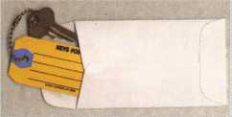

ANDOVER LOCK & KEY SERVICE

3221 LAKESIDE HWY.  
ANDOVER MA 05242  
(508) 626-1111

o

**FREE Printing of Your Ad Copy on bac**

LAKE VIEW  
LOCKSMITH

24 Hour Service s

(845) 556-LOCK

Stock # KTE3 Actual Size: ZVi' x 4W Added security and finishing touch when presenting keys to your customers

♦ 100 200 500 1000

10.50 17.00 37.50 65.00

QUANTITIES100 200 500 1000 2000 3000 5000

**\*** KEY TAGS with CHAINS or RINGS 32.00 42.95 83.95 115.00 195.00 269.00 395.00

YOUR CHOICE OF CHAINS OR RINGS - IF NOT SPECIFIED WE SHIP CHAINS

**Key Tags Only (no chains or rings)** - Deduct 10% from above prices  
National Logos - No Charge / Custom Logos - Add $25.00 and supply clean B & W artwork

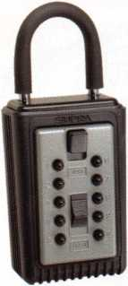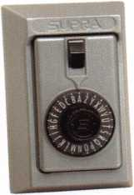

**COMBINATION KEY BOXES**

©SUPRA

**ALL METAL**

**PROFESSIONAL**

**SERIES LOCK BOXES**

Both models now have weather resistant  
ALL TITANIUM METAL CONSTRUCTION  
with metal back and buttons. Both models  
are also available with PUSH BUTTON  
COMBINA TION LOCKS that are easy to  
set & reset.

**DIAL**

1-4 36.95 EA. / 5-9 33.95 EA.

10 or MORE 30.95 EA.

**PUSHBUTTON I**

1-4 37.95 EA. / 5-9 34.95 EA.

10 or MORE 31.95 EA.

**No Home Should Be Without One**The Surface-Mount S-5 Supra  
Lockbox is a product you can provide to  
any homeowner, easily priced to your  
customer in the $50.00 range installed  
(simple 4 screw installation). Carry one

with you at all times to demonstrate - **Stock # S5-PUSHBUTTON**once shown it sells itself I! Surface Mount Unit

Key Storage Lock Box

SALL METAL Construction  
t/ Great Economical Pricing

* Simple to set/ Simple to open
* **5** Year Warranty

**Stock #SLK100  
Blue**

**Stock # C3-PUSHBUTTON**

Removable KeyBox, DoorGuar rubber bumper protects surfaces

**Stock #C3-DIAL**

Removable KeyBox  
DoorGuard rubber bumper protects surfaces

**Stock #S5-DIAL** Surface Mount Unit

ShurLok has designed an all-metal key storage box that is the safest, most secure lock box on the market. Separate easy to set combinations open the shackle and key compartment — and the combinations can be changed in seconds. The ShurLok is so simple to use a child can open it, yet so versatile it will satisfy the Real Estate professional or anyone requiring key access in a lock box. Unique double combination allows all users access to key(s) while allowing only authorized users access to the shackle and will prevent lock box removal or theft.

**Set your own combination**

The combination can be changed in seconds — without special tools or disassembly. Changing the shackle combination also automatically changes the combination for the sliding key storage door.

**1 to 9 $19.95 ea.**

**10 or more $17.95 ea.**

***if color is not specified we ship blue***

**Stock #SLK100R**

**Brick Red**

change

button

**10,000**

**Combinations**

**Possible!**

Changing the combination

for the shackle  
only takes a few seconds  
with a simple turn  
of the change button.

**\*$7.00 SHIPPING CHARGE ADDED PER ORDER** ny residents add applicable sales tax

**SANZO SPECIALTIES, INC. BOX 68 ENDICOTT, NY 13760**

**TOLL FREE: 1-800-222-4041 FAX: 607-748-0507**



***VISA***

***Maste* i**

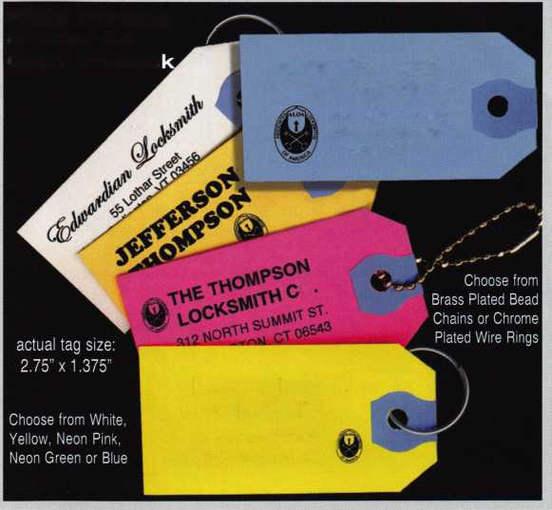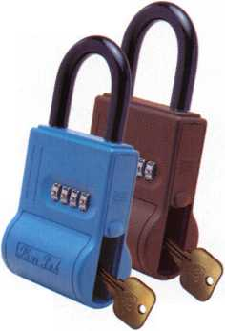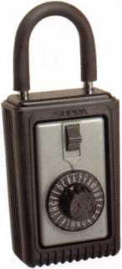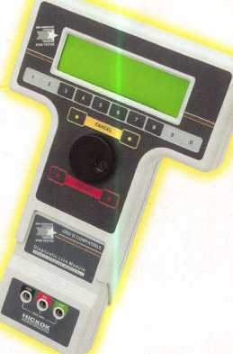

**Transponder**

I m**- ****** . * i i ir^l

**Profits**

**You re never on your own.,**

**Toll Free Tech Support**

1-800-342-5080

for more information visit

**[www.hickok-inc.com](http://www.hickok-inc.com)**

Say "YES" to  
$100 phone calls

How much of your money

have you sent to the  
local Ford dealer?

8008LA New Generation STAR

Use the Ford factory tool to program transponder keys for ^ ALL Ford/Mazda vehicles.

Keep the money in your pocket!

NGS

Complete

Ford/Mazda

transponder

coverage

PLUS the

ability to clear ALL

Diagnostic

Service Codes

"I've lost my Taurus I  
can you make a new

